

Shipboard Meteorological System
MetAcq Operator’s Manual

Shipboard Technical Support Revision 1.84
20 April 2004

1. General Information 4
1.1.0 Meteorological Acquisition Program 5
1.2.0 Minimum Systems Requirements 5
1.3.0 Contact Information 5
2. Meteorological Sensor types 6
3. Installation 8
3.1.0 Program setup and corrections file 8
4. Operation 9
4.1.0 Startup Procedure (quick) 9
4.2.0 Startup Procedure (detailed) 9
4.2.1 Modes of Operation 9
4.2.2 Configuration File Select 9
4.2.3 Time Synchronization 10
4.2.4 Display Modes 10
4.2.5 Enable Data Averaging 10
4.2.6 Status Indicators 10
4.3.0 Program Operation 11
4.3.1 GPS Display - Setting Waypoints 15
4.3.2 Winch Display 16
4.4.0 Program Termination procedure 18
5. Connecting to the WEB Server 19
5.1.0 Setting up the Web Browser 19
5.1.1 Downloading images 20
5.1.2 Network tips 20
6. Copying Data Files 21
7. Configuring Data Input Ports 22
7.1.0 Functional Description 22
7.1.1 RS232 22
7.1.2 RS222 22
7.1.3 RS485 22
7.1.4 UDP (User Datagram Protocol) 22
7.1.5 Analog Input devices 22
7.2.0 Input Port Data Types 23
8. Sending Serial Data 24
8.1.0 Functional Description 24
8.1.1 Serial Output Data Types 24
9. MET Input/Output Configuration 25
9.1.0 Module Activation Section 25
9.2.0 General Section 26
9.3.0 Input Module Setup and Calibration Section 27
9.3.1 MSP Module Setup Parameters 29
9.3.2 MCP Module Calibration Parameters 31
9.3.3 Calibration Method types 31
9.3.4 Examples of setting up an Input Module section 34
9.4.0 Output Module Setup Section 36
10. Data File Format 41
10.1.0 MET data file format description 41
10.2.0 MET log file description 42
11. MET System Calculation Methods. 43
11.1.0 REFERENCES 44
Appendix A MET Parameter Index 45
Appendix B NMEA-0183 Standard Sentence Formats 47
Appendix C Miscellaneous Message Formats 53

1. General Information

The Shipboard Meteorological Acquisition System (MetAcq) acquires, filters, averages, corrects, displays and distributes meteorological sensor data from a wide variety of sensor types and data input devices.

Meteorological sensors such as ones made by RM Young, Vaisala, Alden, Coastal
Environmental Systems, Seabird, FSI, Omega and most sensors that have an RS485, RS422, RS232 digital interface or any analog sensor that can output a voltage, frequency or 4-20ma current can be accommodated.

A typical system measures air temperature, barometric pressure, wind speed/direction, relative humidity, short wave radiation, long wave radiation, seawater temperature and seawater conductivity. Sensor information is combined with time and GPS position information and displayed on the local video display or Web Server and written to data files. The main acquisition device is a Windows based computer that has at least two serial ports. Data can be acquired simultaneously on all enabled ports. One or more ports can be configured to support RS485 communications through RS232 to RS485 converters. Sensors that have analog outputs are first connected to signal conditioning modules that are physically located near the sensor. These modules then convert the analog signal to RS485 that is then routed to the lab. Collected data is stored on data files at user-selected intervals. This interval is typically once every 30 seconds. Acquired data that has been collected from the sensors (uncalibrated) is stored in an uncorrected data file. Data that has been corrected by applying the most recent precruise calibration data is stored in a corrected data file.

Atmospheric meteorological sensors are generally located on either the forward part of the ship on the MET mast and/or above the ship's upper bridge deck. Sensors that measure seawater properties are generally located near the uncontaminated seawater intake area or in one of the ship's laboratories that has a connection to the uncontaminated seawater line.

At least once a year all Sensors are removed from the vessel, refurbished and calibrated at an appropriate shore based maintenance/calibration facility. Calibration data for each sensor is kept onboard each vessel and entered into the shipboard acquisition/setup file that is used by the acquisition program to correct sensor data for display and storage.

1.1.0 Meteorological Acquisition Program

The acquisition program was written in the Labview programming language. It acquires, displays and stores meteorological data in real-time.

Main features:

1. Acquire data from any number of sensors or instrumentation
2. Data Displays present data in numerical form (either calibrated or uncalibrated)
3. Real-time 18-strip chart displays that chart user selected data vs. time.
4. History scroll bar on each strip chart that allows viewing of previously displayed data
5. Ability to output hardcopy of the displayed data.
6. Write data to files or serial devices at user selected intervals.
7. Variable user defined data output formats that can be output to serial port or file.
8. Ability to playback and view any standard data file.

1.2.0 Minimum Systems Requirements

Microsoft Windows 2000
Pentium II 800MHZ or higher processor
XGA Video card and monitor capable of 1024x768 16 bit color 64MB RAM
2-34 RS232 Comm ports
Installed on hard drive 1 GB or higher
National Instruments Labview Runtime engine v7.0
National Instruments VISA Runtime engine v3.01
STS MetAcq.exe Acquisition program

1.3.0 Contact Information

For help or assistance with any part of the meteorological system contact:

Shipboard Technical Support 0214
Shipboard Electronics Group
tel (858)534-1907
fax (858)534-7383
email: all-at-seg@odf.ucsd.edu

Meteorological Acquisition Program written by:
Carl Mattson
Shipboard Technical Support 0214
cmattson@ucsd.edu
tel (858)534-1907

2. Meteorological Sensor types

A sensor type is a software module that produces one complete data set for a particular function. For example, WND is a module of the wind sensor type; it consists of two sensors that output one data set that contains two raw values – 1.Wind Speed, 2.Wind Direction. From these two raw values, calculations may be applied to output corrected values as well as calculated values. For example the wind sensor type can be set to output True Wind Speed and True Wind Direction as well as the relative values. Each sensor type has an ID that is similar to the address values of the older Alden IMET system modules. However, in this case the sensor ID’s are no longer address values with the exception of an installation that still uses the Alden Imet modules.

The first three letters of the sensor modname must begin with one of the following Type designators. The next two characters should be an ID to determine which module is selected. Each sensor used on SIO ships is assigned it's own ID. In this system there are 30 predefined module types that cover the most requested sensor types.

Item | TYPE | Description | Associated Parameters (Appendix A)
1 | TMP | Air Temperature | AT
2 | HRH | Relative Humidity, Temperature | RH, RT, DP
3 | BPR | Barometric Pressure, [Compensation Temp] | BP, BC
4 | PRC | Precipitation | PR, PT
5 | WND | Wind Speed, Wind Direction | WS, WD, WK, TK, TW, TI
6 | SWR | Short Wave Radiation | SW
7 | LWR | Long Wave Radiation Dome Temperature,  Body Temperature, Thermopile voltage | LW, LD, LB, LT
8 | FLW | Flowmeter | FM, FI
9 | SST | Surface Seawater Temperature | ST
10 | SSC | Surface Seawater Conductivity | SC
11 | VLT | A/D Volts | VT
12 | FLU | Fluorometer | FL, TB
13 | XMS | Transmissometer | TR, BA
14 | OXY | Oxygen | OC, OT, OS, OX, OG
15 | TSG | Thermosalinograph | TT, TC, SA, SD, SV
16 | USP | Unspecified (user defined) | XX
17 | PAR | Surface PAR | PA
18 | AWT | Auxiliary Water Temperature | WT
19 | AXT | Auxiliary air Temperature | AX
20 | IST | Instrumentation | IP, IT, IS, IA, IV, IX
21 | PRS | Pressure | PS
22 | PDR | Water Depth | BT
23 | NME | NMEA messages | LA, LO, CR, SP, GT
24 | GYR | Gyro | GY
25 | ASH | Ashtech Heading, Pitch, Roll | SH, SM, SR
26 | TSV | Time Server | TS
27 | WCH | Winch Wire Out, Wire Speed, Tension | ZO, ZS, ZT
28 | ALK | Alkalinity (pH) | PH
29 | VRU | Vertical Reference Unit (Pitch, Roll, Heave) | VP, VR, VH, VY, VX
30 | SOW | Ship’s Speed Log (Speed over water) | SL

Sensor Type Default Settings
Sensor Type | Num  Raw Values | Num  Cor Values | Precision | Parameter Tag | Range MIN | Range  MAX
TMP | 1 | 1 | 2 | AT | 4.00E+1 | 5.00E+1
HRH | 2 | 3 | 2  2  2 | RH  RT  DP | 0.00E+0  -4.00E+1  -4.00E+1 | 1.00E2  5.00E1  5.00E1
BPR | 1 | 1 | 2 | BP | 8.00E+2 | 1.10E+3
PRC | 1 | 1 | 1 | PR | 0.00E+0 | 5.00E+1
WND | 2 | 4 | 1  1  1  1 | WS  WD  TW  TI | 0.00E+0  0.00E+0  0.00E+0  0.00E+0 | 2.00E+2  3.60E+2  2.00E+2  3.60E+2
SWR | 1 | 1 | 1 | SW | -5.00E+3 | 5.00E+3
LWR | 3 | 4 | 2  2  1  1 | LD  LB  LT  LW | 2.00E+2  2.00E+ 2  -5.00E+3  -2.00E+3 | 5.00E+2  5.00E+2  5.00E+3  2.00E+3
FLW | 1 | 1 | 1 | FI | 0.00E+0 | 1.00E+3
SST | 1 | 1 | 3 | ST | -5.00E+0 | 5.00E+1
SSC | 1 | 1 | 3 | SC | -5.00E+0 | 9.00E+1
VLT | 1 | 1 | 3 | VT | -1.00E+2 | 1.00E+2
FLU | 1 | 1 | 3 | FL | -5.00E+2 | 1.00E+5
XMS | 1 | 2 | 3  3 | TR  BA | 0.00E+0  -1.00E+2 | 1.00E+2  1.00E+2
OXY | 2 | 4 | 3  3  3  4 | OC  OT  OX  OS | -5.00E+0  -5.00E+0  -1.00E+1  -1.00E+1 | 1.00E+4  5.00E+1  1.00E+4  1.00E+4
TSG | 2 | 5 | 3  3  3  3  3 | TT  TC  SA  SD  SV | -5.00E+0  -5.00E+0  0.00E+0  0.00E+0  1.40E+3 | 5.00E+1  1.00E+2  8.00E+1  5.00E+1  1.60E+3
USP | 1 | 1 | 3 | XX | -1.00E+6 | 1.00E+6
PAR | 1 | 1 | 2 | PA | -1.00E+5 | 1.00E+5
AWT | 1 | 1 | 2 | WT | -5.00E+0 | 5.00E+1
AXT | 1 | 1 | 2 | AX | -4.00E+1 | 5.00E+1
PRS | 1 | 1 | 2 | PS | -5.00E+1 | 1.00E+5
PDR | 1 | 1 | 1 | BT | -5.00E+0 | 1.50E+4
NME | 5 | 5 | 6  6  1  1  1 | LA  LO  GT  CR  SP | -9.00E+1  -1.80E+2  0.00E+0  0.00E+0  0.00E+0 | 9.00E+1  1.80E+2  8.64E+4  3.60E+2  5.00E+1
GYR | 1 | 1 | 1 | GY | 0.00E+0 | 3.60E+2
ASH | 3 | 3 | 1  1  1 | SH  SM  SR | 0.00E+0  -3.00E+1  -6.00E+1 | 3.60E+2  3.00E+1  6.00E+1
TSV | 1 | 1 | 0 | TS | 0.00E+0 | 8.64E+4
WCH | 3 | 3 | 1  1  1 | ZO  ZS  ZT | -2.00E+4  -2.00E+4  -5.00E+4 | 2.00E+4  2.00E+4  5.00E+4
ALK | 1 | 1 | 2 | PH | -1.50E+1 | 1.50E+1
VRU | 3 | 5 | 1  1  2  1  1 | VP  VR  VH  VY  VX | -6.00E+1  -6.00E+1  -1.50E+1  -6.00E+1  -6.00E+1 | 6.00E+1  6.00E+1  1.50E+1  6.00E+1  6.00E+1
SOW | 1 | 1 | 1 | SL | 0.00E+0 | 8.00E+1

The above values are what the program uses for default values.
Default settings for any sensor type can be changed and/or can be overridden in the ACQ file using the Keys: TAGS-C, TAGS-R, PRC-C, PRC-R, RANGE (see Section 9).

3. Installation

Certain applications must be installed on the computer before the system can operate.
1. National Instruments Labview Runtime engine v7.0
2. National Instruments VISA Runtime engine v3.01
3. STS MetAcq.exe Acquisition program and supporting files

Refer to documentation supplied by National Instruments for instructions on installing the NI Labview Runtime engine and NI VISA Runtime engine. The Labview Runtime engine should be installed prior to the VISA Runtime engine.

The Windows path name is set to include C:\Wbin in the main path.
The following files are installed in C:\Wbin:
MetAcq.exe MetAcq.ini MetAcq.dsp settime.dll

Web Server support files are installed in C:\Wbin\www.

Met system manuals and documentation are located in C:\MET or the selected data directory.

3.1.0 Program setup and corrections file

This file contains serial port, program parameters and sensor setup and calibration data that the program uses for the following operations:

1. Activation and setup of computer serial ports
2. Activation and selection of sensor input modules
3. Setup of sensor address and communication parameters
4. Setup of desired correction/calibration algorithm
5. Sensor calibration coefficients
6. Data averaging parameters
7. Specify user defined output modules for serial port/data file writes

Program setup and corrections file <name>.ACQ is located in a user-designated directory (default directory is C:\MET). All MET data is written to the same directory that the selected ACQ file is located.

See Section 7 and Section 9 for details on the setup and corrections file.

4. Operation
After the Met acquisition computer is properly configured and setup then the following procedures can be used to perform program operations.

4.1.0 Startup Procedure (quick)
- Power ON the MET computer
- Ensure power is ON to all Met sensors
- Observe that the Windows operating system is properly booting up.
- The acquisition program will start. The program control panel will appear on the monitor.
- At this point do one of two things.
  - Do nothing; the program will start in about 30 seconds.
  - Click on the green control button labeled <Start>

Note that the acquisition program is set to start automatically upon boot up.

4.2.0 Startup Procedure (detailed)
1. Ensure power is ON to all Met sensors
2. Ensure acquisition computer is powered up and booted up to the Windows operating system
3. On the Windows desktop display, using mouse, select the icon labeled MetAcq.exe
4. After the acquisition program is loaded, the user will see a control panel. At this point the program is in Standby. During Standby mode select the desired met configuration file, mode of operation, type of display, enable/disable of automatic time sync and enable/disable data averaging. The lower control panel also contains several status indicators that can be observed during program operation.
5. After making the desired selections, click on the green control button labeled <Start>

4.2.1 Modes of Operation
1. <Acquire> This is the normal mode for data acquisition
2. <Playback> Playback any archived data file
3. <Cascade> Display data sent by RS232 from the primary acquisition PC
4. <Emulate> Sensor Emulation mode

4.2.2 Configuration File Select
The configuration file used by the acquisition program may be selected by using the indicated control. Just click on the little yellow folder symbol on the right side of the control. The configuration files are indicated be the file extension ACQ (For example SPROUL.ACQ).

4.2.3 Time Synchronization
If a Network timeserver is connected to the network then the system time of the MET acquisition computer is automatically synchronized to the timeserver time using NTP protocol. When no network time server is connected then the MET acquisition computer the system computer time will be synchronized to the time obtained from the GPS.
When GPS Sync is enabled, and it is desired to synchronize the time manually, then click on the Time Sync control located just below the GPS Sync control.

4.2.4 Display Modes
1. <Strip Chart4> Selects 4 strip charts with 30 numeric parameter display indicators.
2. <Strip Chart6> Selects 6 strip charts with 30 numeric parameter display indicators.
3. <Strip Chart8> Selects 8 strip charts (Numeric displays are not shown in this mode).
4. <Tabulated> Selects Tabulated display with 30 parameter display indicators.
5. <Tabulated-GPS> Selects Tabulated display with GPS indicators and 30 displays.
6. <Fixed> Selects Fixed display showing the basic suite of MET data.
7. <Winch> Selects Display With large Winch readouts
The Display mode has no effect on what data is stored in the MET data files. The information in the data files is determined by which sensors are activated in the configuration file.

4.2.5 Enable Data Averaging
When ON data averaging is enabled. The averaging setup parameters must be specified in the module section of the setup file (see section 9.3.0). Averaging can be enabled or disabled individually for any sensor. Averaging time can also be specified for any sensor. There are two types of averaging available. 1-Normal, 2-Vector. Vector averaging is used only on sensors that output in angular degrees such as wind direction.

4.2.6 Status Indicators
Runtime indicator – displays the length of time the program has been executing without interruption.
Scans Per Second (SPS) indicator – displays the number of times per second that the program scans through all of the sensors. This gives a general idea of how well the program is working. With several sensors the SPS will be lower; with few sensors the SPS will be higher. Generally the SPS should always be above 0.5 to indicate proper program execution.
Data Files indicator – displays the name and path of the data file that is currently being written. There are at least two files that the program updates every write interval. One file for the corrected data and the second for the uncorrected data. A new set of data files are started at the beginning of each (GMT) day beginning at 0000Z. Section 10 describes the data files.
SIZE indicator – displays the size in bytes of the data files. After each data write interval this value will increase.
CHK MOD indicator – Displays a list of sensors that fail to respond or output data. If a failure has been indicated there are 3 possibilities.
- The sensor(s) have failed
- The sensor power is OFF
- The sensor(s) have been disconnected.

4.3.0 Program Operation

After the program has been started as described in sections 4.1.0 or 4.2.0, the main display Window appears. This Window will be one of eight different configurations depending on the Display Modes setting. The Display Mode setting may be changed to another type of display at any time. In each display mode every window has it’s own menu to select desired values to display and plot. To change the displays – click the control button to access the pop up menu on the upper left – labeled <Displays>. In the popup display sensor data, sensor number and number of decimal places can be changed. When finished making selections click on the <X> on the upper right corner of the display.

Screenshot of Variable Selection Menu for Upper Display Indicators on Strip Charts
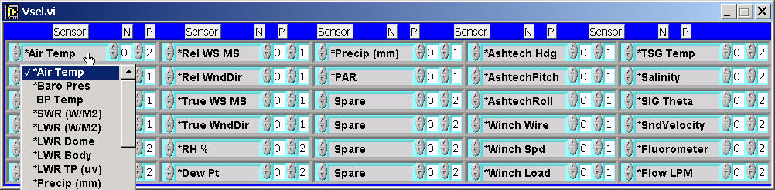

The <Plot Scales> control enables a popup where parameters and attributes are selected for plotting data on strip charts. In this popup display select the sensor data, sensor module, number of decimal places, auto scale enable, minimum scale value and maximum scale value. The sensor module selection on either the display selection or plot section allows the selection of redundant sensors. For example, if there were two air temperature modules and it is desried to chart the second one, select it’s module number. Module numbers are numbered starting from zero. Zero being the first module. The minimum and maximum scale values can only be accepted if the autoscale is turned OFF. When autoscale is ON the program automatically adjusts the minimum and maximum scale values. The AUTOSCALE is initially enabled but if it is desired to manually set the scales of the Plot. Click on autoscale to disable it. Then either enter the Min/Max values in the Plot Scales popup or simply click on the upper and lower scale values on the chart, then enter the desired values.

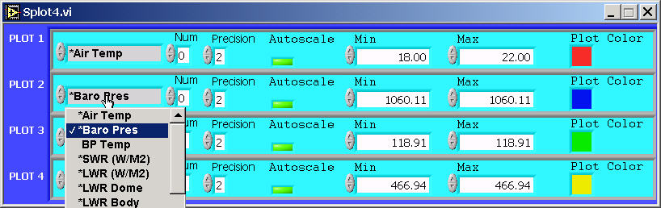

Screenshot of Strip Chart 4-plot after activating plot selection menu
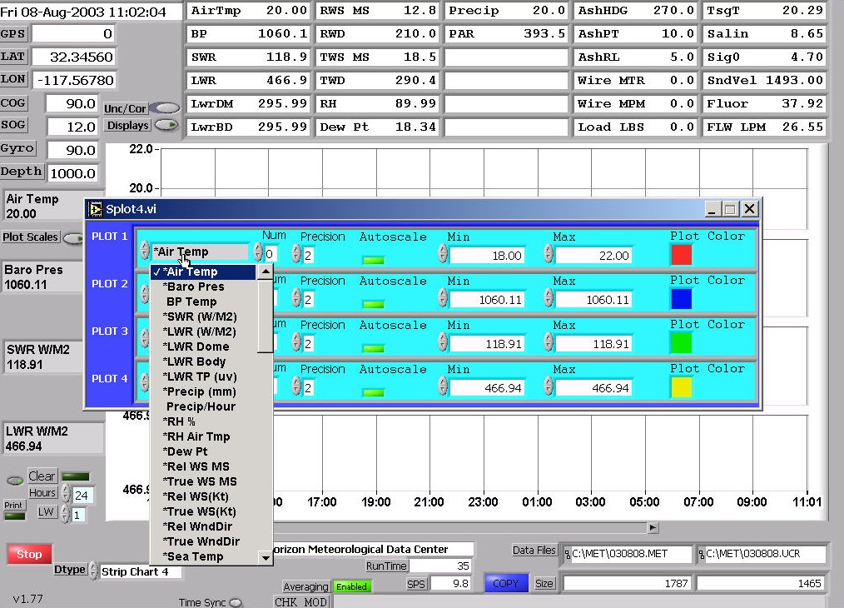

The strip charts have a history bar. If it is desired to view data that has already scrolled off the screen move the history bar to the desired setting.
The Clear Plot control clears the plot and plot history.

The Time Scale may be changed to any value in hours. Initially it is set to 24 hours. To change, move the mouse on the control and click to enter the value. Each time the Time Scale is changed it may be necessary to also click on the clear plot control to view the new chart time scale.

The PRINT control allows the plot that is currently displayed to be sent to a printer. Before using this control the printer must be properly connected, have a windows driver installed, must have paper and be turned ON. The printer control may be disabled in the program setup file using the keyword PRINT_EN = FALSE. (Section 9)

Screenshot of Strip Chart 4-Plot 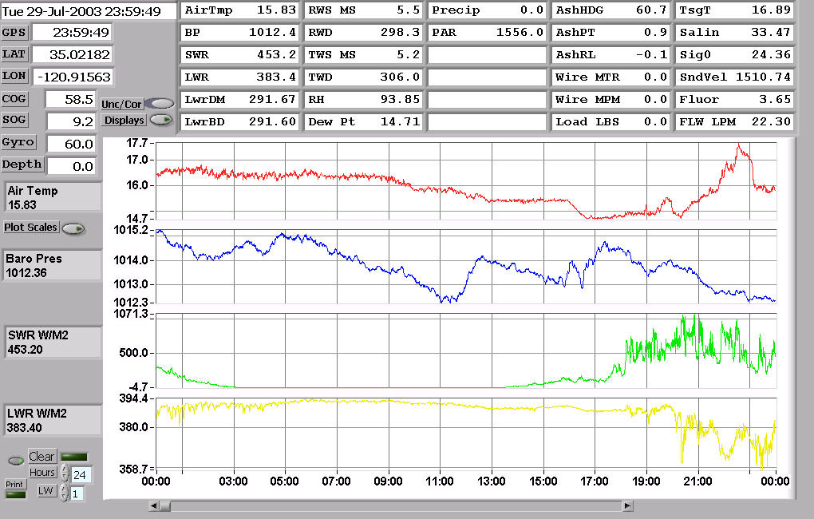

Screenshot of Strip Chart 8-Plot
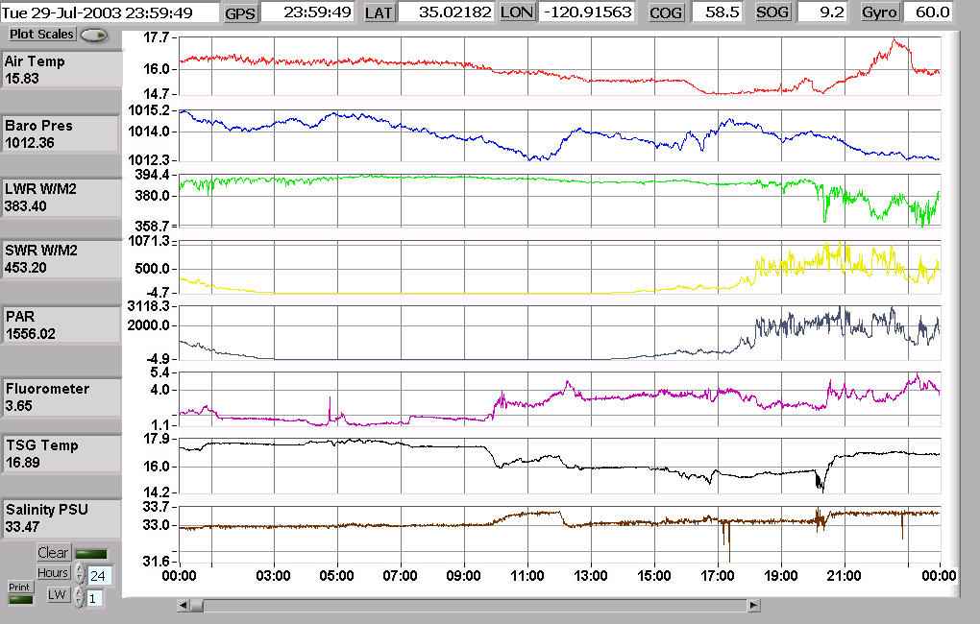
Screenshot of Tabulated Display
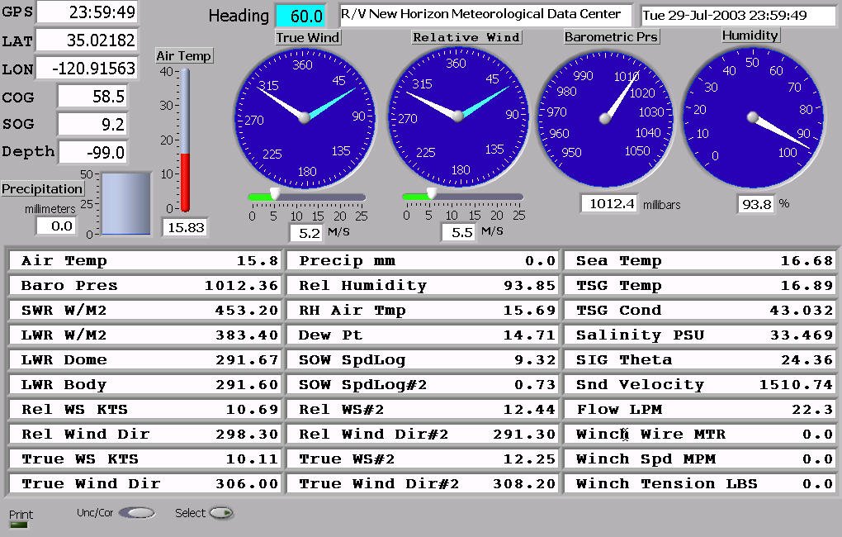

Screenshot of Variable Selection Menu for Tabulated Display
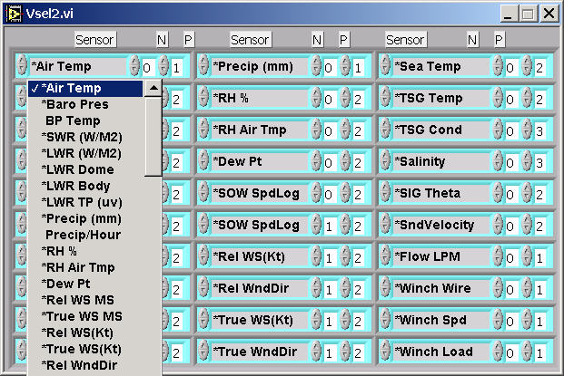

4.3.1 GPS Display - Setting Waypoints
On the Display mode selector control, set the display to Tabulated-GPS. Waypoints may be viewed and selected on the right side of the display. Once selected the following data will be calculated and continuously updated in the appropriate displays.
- ETA – Estimated Time of Arrival to selected waypoint.
- EDA – Estimated Date of Arrival.
- TTG – Time to go before arriving at waypoint.
- Distance in Nautical Miles to the selected waypoint
- Bearing from the present location to the selected waypoint

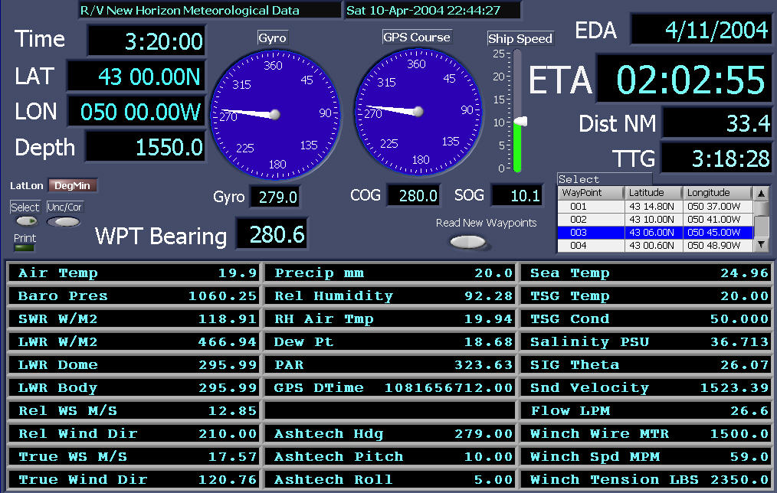

In order to utilize this function it is necessary to setup a waypoints file and place this file in the same directory that the ACQ file is in and where the data files are written. Upon startup the program first looks for a file called <Waypoints>, if this file is not present then it will look for a file called <MetAcq.wpt>. The format of the waypoints file only allows one type of format as follows. Station, LAT, LON (deg min) 001, 32 30.0N 117 30.0W

Test 42 46.32 N 58 54.52 W 3100
001 43 14.80 N 50 37.00 W 81
002 43 10.00 N 50 41.00 W 85
003 43 6.00 N 50 45.00 W 95

The Format of the MetAcq.wpt file can be one of three types of formats as follows:

# MetAcq Waypoints List
# delimit by commas or tab
# FORMAT=0 Station, LAT, LON (decimal) 001, 32.500, -117.500
# FORMAT=1 Station, LAT, LON (signed deg min) 001, 32 30.0 -117 30.0
# FORMAT=2 Station, LAT, LON (deg min) 001, 32 30.0N 117 30.0W
# Waypoint name or number, Latitude, Longitude
#
FORMAT=2
Test 42 46.32 N 58 54.52 W 3100
001 43 14.80 N 50 37.00 W 81
002 43 10.00 N 50 41.00 W 85
003 43 6.00 N 50 45.00 W 95

In both types of files, the waypoint can be a number or a name. Do not use spaces within the name of a waypoint. E.g. a waypoint called San Diego should be designated as San_Diego. Lines beginning with ‘#’ are comments and ignored. Any number of waypoints may be entered in the file.

The Waypoints file can be read into the program at any time. It is not necessary to stop and start the program. Just place the new waypoints file in the data directory, then click on the control labled <Read New Waypoints>. The new waypoints will then be available for selection.

If the Bearing to waypoint is greater than +/- 45 degrees of the ship’s heading the indicated ETA will say <CHK WPT>. Once the ship’s heading (COG) agrees (more or less) with the Bearing then a calculated ETA will be displayed.

4.3.2 Winch Display
On the Display mode selector control, set the display to Winch. Winch readouts include Winch wire out in Meters, Winch Speed in Meters/Minute and Winch tension in pounds (LBS). If there is a CTD input signal then CTD depth, CTD Speed (calculated from pressure), and CTD Altimeter readouts will also be displayed otherwise these areas will be blank. There is a Strip chart for winch tension. The max Y-scale in pounds (lbs) can be set by the Y-scale control. The max X-scale in time (hours) can be set by the X-scale control. If there is more than one winch, the selected winch will be displayed. The winch number can be changed by the Sel control. The first winch is ‘0’, the 2nd is ‘1’ and so on.
If there is a signal from the vertical reference unit then pitch, roll, ship’s trim and list will also be displayed.

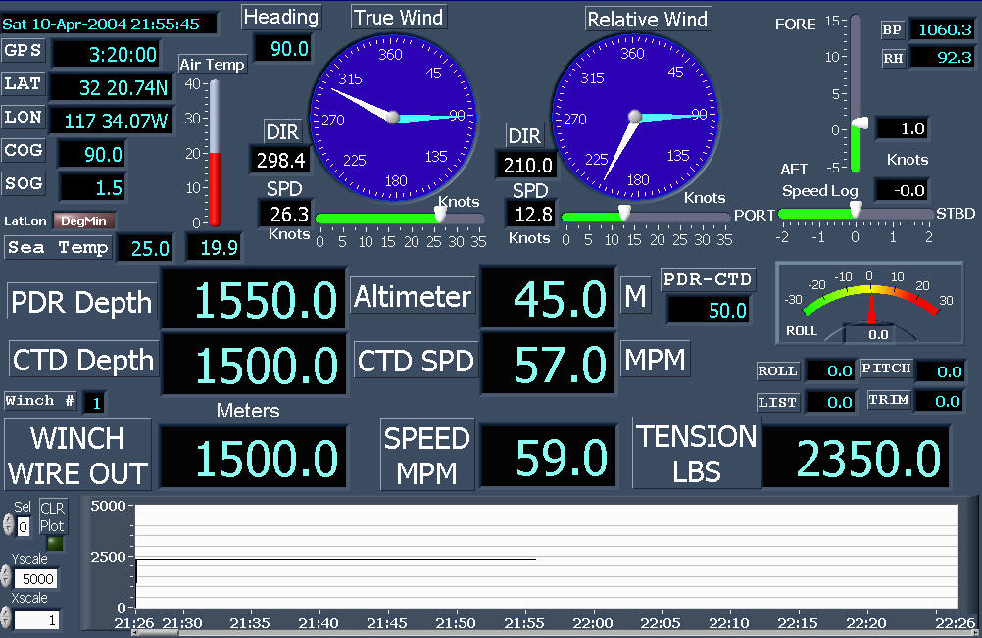

The winch signals are usually connected via RS232 or RS422. The ACQ file is edited to include a Winch data sensor section. This section is defined as WCH. Examples of winch input sections in the ACQ file are indicated below:

Winch Wire, Speed and Tension come in on separate serial ports  Port 16 is Wire out, Port 17 in Speed Port 18 is Tension.  Data is NOT written to the data file. | Winch Wire, Speed and Tension come in on the same port in the format. Port 20 is the winch input port. Data written to file.  S1000, V60, T1000
Serial Ports Configuration (Refer to Section 7)  UNIT16 1 COMM16 2400 NONE 8 1 Winch Wire Out  UNIT17 1 COMM17 2400 NONE 8 1 Winch Speed  UNIT18 1 COMM18 2400 NONE 8 1 Winch Tension | Serial Ports Configuration (Refer to Section 7)  UNIT20 1 COMM20 9600 NONE 8 1
[WCH01] | [WCH01]
SENSOR = Winch Readouts | SENSOR = Winch Readouts
MODEL = DESH05 | MODEL = DESH05
SERIAL = 001 | SERIAL = 001
MFG = Markey | MFG = Markey
LOCATION = Winch Deck | LOCATION = Winch Deck
OWNER = SIO | OWNER = SIO
ADDTOFILE = FALSE | ADDTOFILE = TRUE
CMD = 0 | CMD = 0
CMD2 = 0 | MSP = 20 3 0 0 10 0 3 1 2 3 0 0 0 0 0
CMD3 = 0 | MCP = 1 0 3 0 0 0 0 0 0 0 0 0
MSP = 16 3 0 0 10 0 1 1 0 0 0 0 0 0 0 | DELIMITERS = \s S V T
MSP2 = 17 3 0 0 10 0 1 1 0 0 0 0 0 0 0
MSP3 = 18 3 0 0 10 0 1 1 0 0 0 0 0 0 0
MCP = 0 1 3 0 0 0 0 0 0 0 0 0

A description of Sensor Module sections can be found in section 9.
A description of Data Input Ports can be found in section 7.

4.4.0 Program Termination procedure
To terminate the acquisition program move the mouse to the red control labeled <Stop> located in the lower left side of the screen. Click the mouse on this control. A Popup window will appear to verify that acquisition is to be stopped. If this is confirmed then click on the red <STOP> control located in the popup window. The acquisition program will stop acquisition and data file logging and then enter standby mode.

To End the acquisition Click on the red <Stop> button

Control Panel During Acquisition

After the Verify popup appears, Click on the red <Stop> button to stop the program.

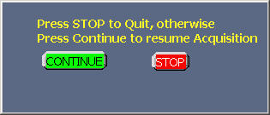

The Program is now in standby.
The program can then be reactivated at any time by hitting the green <Start> control.

If it is desired to quit the acquisition program completely, click on the control labeled <EXIT>.

The <EXIT> control can only be reached during standby mode.

5. Connecting to the WEB Server

The meteorological displays can be viewed on any computer that is connected to the network. A web browser such as Microsoft Internet explorer or Netscape that is running on any computer such as Solaris, Linux, Unix or Apple operating system can access the MET Display.

The Web server function is independent of any computer or system on the network. It will work in either a network that has a Unix or Windows name server station or in a network that consists of only the MET acquisition computer and the user’s local computer.

5.1.0 Setting up the Web Browser

On the MET acquisition PC the file METACQ.INI is usually located in C:\Wbin directory.
Ensure that it contains the following statement:
[MetAcq]
WebServer.Enabled=True

Any panel can be viewed on any browser regardless of the Display Mode setting of the acquisition computer. Any Strip chart can be viewed on the browser at the same time that Tabulated displays or another strip chart type is shown on the acquisition PC. The following panels are available.

Display Mode | Panel | Display Mode | Panel
Strip Chart 4 | Metdisp.vi | Tabulated-GPS | MetGPS.vi
Strip Chart 6 | Metdisp6.vi | Fixed | MetFixed.vi
Strip Chart 8 | Metdisp8.vi | Winch | MetWinch.vi
Tabulated | Metnum.vi

The user’s computer needs to be connected to the same network that the MET acquisition PC is connected. It must be configure to the network in the standard method used on a particular vessel or laboratory. The IP number is assigned or DHCP is used.

On the user’s computer, start the web browser. If using Netscape or Internet Explorer press the <F11> key (on the user’s computer). This will put the browser in full screen mode for best viewing. (To switch back just press <F11> again).

There are three methods that can be used to view the met display on a web browser.

- In the browser web address section enter the network name or IP number of the MET PC. The MET home web page will now be visible. From this web page select the link to the desired display or follow the navigation arrow in lower right of the screen. This arrow can be followed on each panel is succession.
- Using method#2 it is possible to go directly to the desired screen without using the above menu. Enter the network name or IP number of the MET PC followed by one of the following:
/metdisp4.htm /metdisp6.htm /metdisp8/htm /metnum.htm /metgps.htm metfixed.htm
E.g. http://metpc/metdisp.htm
- The third method is as follows:
Assuming the MET computer's ID is called metpc and Strip Chart 4 display intended to be selected.
http://metpc/.snap?metdisp.vi

If DNS is not enabled or there is no host file then use the IP number of the MET acquisition computer e.g.

http://100.100.100.001/.snap?metdisp.vi

For Continuous updates use the following:
http://metpc/.monitor?metdisp.vi&refresh=15&lifespan=0

Refresh specifies the number of seconds between updates.Lifespan is the number of seconds that the WEB page remains active. Lifespan=0 specifies no time out.
Using Method #1 the following screen will appear on the local computer. Select the link to the desired display or click on the arrow on the right side of the page. On the lower right of each page is an arrow to allow going to the next screen in sequence. On the local computer start the browser then enter the address. Press the function key <F11> to get full view.
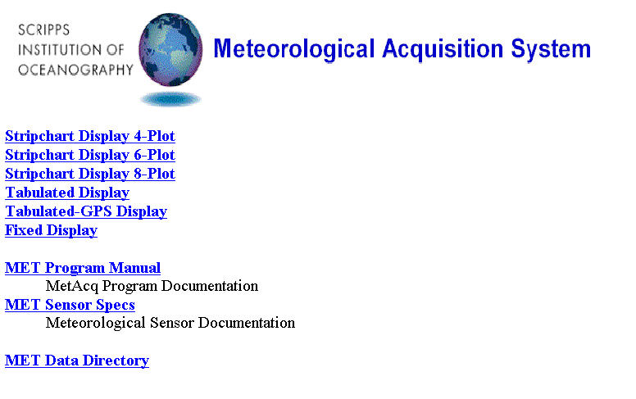

5.1.1 Downloading images
To download any display image such as a strip chart, place cursor on display and right click on the mouse. Select “Save picture as…” then enter filename info to save the file.

5.1.2 Network tips
When connecting to the MET acquisition computer in a network that has no DNS or DHCP server, it may be necessary to change the IP number of the local computer. The first nine numbers should be made the same as the first nine numbers of the MET computer. However, the last three numbers must be a unique number.

6. Copying Data Files

There are several ways to copy data files.
It is not necessary to interrupt the acquisition program.
Files may be copied at any time.

1. Open a Command Prompt Window, then use the COPY command to copy files to the backup
device. For example;
COPY *.MET E:
This will copy only files of type .MET to drive E:

2. Open Windows Explorer, select the data directory, select the desired files to copy, and then select “COPY to folder” then enter the destination directory.

3. Click on the COPY control button located on the acquisition program control panel. Click OK when ready to copy. This will copy all files in the MET data directory onto the computer's ZIP disk. Be sure to insert a formatted, blank zip disk with sufficient free space to hold the files prior to clicking on the control.

4. If the FTP server is enabled and the network is operational, data files may be directly downloaded from the MET PC directly to the local computer. Enter the following command.
ftp <network name of METPC>.ucsd.edu
or
ftp <ip number of MET PC>

5. Files may also be downloaded via the MET PC web server (see section 5).

7. Configuring Data Input Ports

7.1.0 Functional Description
The first part of the acquisition setup file determines how Input ports are assigned as well as the characteristics of each port. Up to 34 ports may be accommodated. In the section that follows, each line begins with a UNIT device number. This number is not the computer's COMM port number but is the Logical Device number that the labview program uses to identify a particular port. There are three basic types of input ports: RS232, RS485 and UDP.

7.1.1 RS232
RS232 devices transmits their signal in a dedicated unbalanced transmission line. The transmitted signal is referenced to signal ground.

7.1.2 RS222
RS422 devices transmits their signal in a dedicated balanced transmission line. In a balanced differential system the voltage produced by the driver appears across a pair of signal lines sometimes referred to as A and B output terminals.

7.1.3 RS485
The EIA RS-485 Standard permits a balanced transmission line to be shared in a party or multidrop mode. As many as 32 driver/receiver pairs can share a multidrop network. Many characteristics of the drivers and receivers are the same as RS422. Each RS485 device is accessed to talk by sending it the correct address and command line string. The instrument then responds to the particular command then it relinquishes the transmission line.

7.1.4 UDP (User Datagram Protocol)
UDP provides simple, low-level communication among processes on computers. Processes communicate by sending datagrams to a destination computer or port. A port is the location where data is to be sent. IP (Internet Protocol) handles the computer-to-computer delivery. IP performs the low-level service of moving data between computers. IP packages data into components called datagrams. A datagram contains, among other things, the data and a header that indicates the source and destination addresses. IP determines the correct path for the datagram to take across the network or Internet and sends the data to the specified destination. Once the datagram reaches the destination computer, UDP moves the datagram to its destination port. If the destination port is not open, UDP discards the datagram.

UDP datagrams that are currently recognized are:
GGA, VTG, GLL, RMC, HDT, SHR (Ashtech), ZDA, MWV, DBT, VHW, VBW, PKE (Knudsen), BPR, IMET_HRH, IMET_WND, IMET_PRC, IMET_SWR, EDO, SSTMP, SSCND, Salinity, Fluorometer and Air_Temp. Many of these datagrams are described in Appendix B and C.

7.1.5 Analog Input devices
MET sensors that output analog signals such as volts, 4-20ma current and frequency are usually connected to an analog to RS485 converter located near the sensor. The converter can be a multichannel or single channel device.

7.2.0 Input Port Data Types
Data Type | Column 2  Function Code | Column 3 | Column 4 | Column 5 | Column 6 | Column 7
RS232, RS422, RS485 | Code 1 | COM Port | Baud Rate | Parity  NONE, EVEN, ODD | Data Bits  7 or 8 | Stop Bits  1 or 2
UDP | Code 80 | Ignored | UDP Port | Ignored |  | Ignored

Everything after Column 7 is ignored by the program. This area can be used for descriptive comments.
# Port and Sensor Configuration/Calibrations file
#
UNIT1 0 COMM1 9600 NONE 8 1 Spare
UNIT2 0 COMM2 9600 NONE 8 1 Spare
UNIT3 1 COMM3 9600 NONE 8 1 RS485 - MET Mast Sensors
UNIT4 1 COMM4 9600 NONE 8 1 RS485 - Flo-thru sensors
UNIT5 1 COMM5 9600 NONE 8 1 RS485 - FSI CT sensors
UNIT6 1 COMM6 4800 NONE 8 1 RS232 Input - GPS Pcode
UNIT7 1 COMM7 9600 NONE 8 1 RS232 Input - Gyro
UNIT8 1 COMM8 9600 NONE 8 1 RS232 Input - Knudsen Depth
UNIT9 1 COMM9 9600 NONE 8 1 RS232 Input - Ashtech
UNIT10 1 COMM10 9600 NONE 8 1 RS232 Input - Time Server
UNIT11 7 COMM11 9600 NONE 8 1 RS232 Output - SB2000 Nav
UNIT12 10 COMM12 9600 NONE 8 1 RS232 Output - VTG, HDT to MRU
UNIT13 17 COMM13 9600 NONE 8 1 RS232 Output - TSG Data to Gyro box
UNIT14 4 COMM14 9600 NONE 8 1 RS232 Output - MET Data to Main Lab
UNIT15 0 COMM15 9600 NONE 8 1 RS232 Output - Surf PAR to SBE11
UNIT16 0 COMM16 9600 NONE 8 1 Spare
UNIT17 0 COMM17 9600 NONE 8 1 Spare
UNIT18 0 COMM18 9600 NONE 8 1 Spare
“” “”
“” “”
UNIT34 0 COMM34 9600 NONE 8 1 Spare

Any port may be assigned to any program UNIT number. But it is not permissible to assign a port more than once. If a UNIT device is disabled then the port number is ignored.

UNIT numbers that assign an active port to a particular sensor are placed in the Sensor
Type setup file in the first number following the <MSP = > keyword. (See Section 9.2.0)

MetAcq Serial Ports configuration
1. a. Unit Device Number
b. Unit Code
0 Disable unit (If zero the sensor will be emulated)
1 Enable unit
2-20 Device Output code (see section 8)

c. COMM port number
d. Baud rate
300 1200 2400 4800 9600 19200 38400 76800 115200
e. NONE No Parity
ODD Odd Parity
EVEN Even Parity
f. Data bits 7 or 8
g. Stop bits 1 or 2

Throughout the ACQ file, if the first character of a line starts with the '#' sign then it is treated as a comment line and ignored by the program. Blank lines are also ignored

8. Sending Serial Data

8.1.0 Functional Description

Serial data of various formats may be transmitted from the Acquisition computer to an external device or distribution network.

To assign output data to a serial port put the appropriate Output Code in the UNIT code location then set the desired baud rate, parity, data bits and stop bits. See section 9.3.0
The following pre-defined outputs are available. To specify user defined outputs see sections 8.13.0 and section 9.4.0
.

8.1.1 Serial Output Data Types
Data Type | Function  Code | Output  Interval | Comments
MET Data (Corrected) | Code 2 | Any | (Format in Section 10)
MET Data (Uncorrected) | Code 3 | Any | (Format in Section 10)
MET Data (Translator Format) | Code 4 | Any | (Format in Section 10)
Seabeam 2100 Sound Velocity | Code 5 | 5 Secs
Seabeam 2100 Navigation | Code 6 | 1 Sec
Seabeam 2000 Navigation | Code 7 | 1 Sec | (Appendix C)
VTG, HDT Message | Code 10 | 1 Sec | (Appendix B)
EM120 Sound Velocity | Code 13 | 1 Sec | (Appendix C)
Surface Par Output | Code 14 | 1 Sec
Calcofi(2003 MET Data Stream | Code 17 | 5 Sec | *
GLL, VTG, DBT, HDT | Code 18 | 1 Sec | (Appendix B)
User Defined | Code 20 | Any | (Section 9.4.0)

*Calcofi 2003 MET Stream
$WICCI,ddmmyy,hhmmss, AT, BP, TK, TI, TT, SA, FL, LA, LO, T*<Checksum><cr><lf>
Precision 2 2 1 1 3 3 3 5 5 1

9. MET Input/Output Configuration

A sensor input module is defined as a sensor or data stream that sends data to the acquisition system. A sensor output module is a user defined data stream that sends data from the acquisition system to an output device such as a RS232 port.

For each sensor module (input device or output data stream) there are three steps to configuring the program.
- Define the sensor module section.
- Assign the sensor module to an active port device such as a RS232 port.
- Activate the module in the Module Activation Section.

The acquisition setup and calibration ACQ file consists of several components:
- Input/Output port definition section. This is where Ports are defined and attributes such as baud rates and data bits are entered (See Section 7).
- Following the Input/Output Ports section is the Module Activation Section. Both Input and Output Modules are activated or deactivated here.
- Next is the Output device section where output data streams are defined.
- Last is the Input device section where all of the input devices are defined. Devices such as Meteorological sensors and GPS NMEA input devices are entered here.

9.1.0 Module Activation Section
After the serial port section, the module selection section follows. Specifying the Sensor ID will activate sensors. Each Sensor ID that is specified must have its associated setup/calibration section attached in the latter part of the setup file.

The word STARTMOD must be placed at the beginning of the sensor list. Each module has a 5 character ID that conforms to the specification from section 2. Each module included in the sensor list must have an entry in the module setup and calibration section.

STARTMOD
PRC01 TMP01 HRH01 BPR01 WND01 SWR01 LWR01 AXT11 VLT05 TSG01 FLW01 WND09 OXY02 AWT02 FLW02 FLU02 PAR01 NME01 GYR01
ENDMOD

The word ENDMOD must be placed at the end of the sensor list. When removing sensors it is only necessary to remove the module from the above list. It is not necessary to delete the sensor section itself.

To disable a module simply delete it out of the string or place a comment character at the beginning of the line that contains all the modules that are to be deactivated. The module can then be reactivated by removing the comment and restarting the program.

9.2.0 General Section
The General section includes miscellaneous information such as Title, Copy file destination, Enable hardcopy print button (PRINT_EN) and Enable/Disable generation of data files in the Translator format (MK_COR and MK_UNC). TIMEOUT is the maximum number of milliseconds the program will wait for a response from a sensor. FileWriteInterval is the interval in seconds between file writes to a data file. SerialWriteInterval is the interval in seconds between serial output strings when the output Code is set to 2, 3 or 4.

General Section Keynames
[GENERAL] |  | Defaults
TITLE | Shipname | TITLE = R/V Sproul
ZIPDIR | Drive Letter | ZIPDIR = E:
PRINT_EN | Enable/Disable Printer TRUE or FALSE | PRINT_EN=FALSE
MK_MET | Enable/Disable MET FileTRUE or FALSE | MK_MET = TRUE
MK_UCR | Enable/Disable UCR FileTRUE or FALSE | MK_UCR = TRUE
MK_COR | Enable/Disable COR FileTRUE or FALSE | MK_COR = FALSE
MK_UNC | Enable/Disable UNC File TRUE or FALSE | MK_UNC = FALSE
MK_LOG | Enable/Disable LOG File TRUE or FALSE | MK_LOG = FALSE
CHART_RATE | Interval in Seconds that the Strip Chart Updates | CHART_RATE = 2.0
TIMEOUT | Timeout in milliseconds to wait for Sensor Response | TIMEOUT = 300
FileWriteInterval | Interval in Seconds between File Writes | FileWriteInterval=30.0
SerialWriteInterval | Interval in Seconds between Serial out messages | SerialWriteInterval=30.0

9.3.0 Input Module Setup and Calibration Section
Each Active module has a section that starts with the 5-character module ID enclosed in brackets. In these sections key names are used to assign sensor characteristics.

Input Module Section Key names
Keys |  | (Example)
SENSOR | Sensor Description | SENSOR = Air Temperature
MODEL | Model Number | MODEL = 41342LC
MFG | Manufacturer | MFG = RM Young
SERIAL | Serial Number | SERIAL = 3944
OWNER | Organization/owner of Sensor | OWNER = STS
CAL_DATE | Calibration Date | CAL_DATE = 03-Feb-03
CAL_LAB | Calibration Lab | CAL_LAB = ODF
LOCATION | Where Sensor is installed | LOCATION = FWD MET MAST
COMMENTS | Any Info | COMMENTS = Primary Air Sensor
CMD | Module address and/or  command line sent to Sensor | CMD = #x\r  (see backslash codes below)
MSP | Module Setup Parameters (see 9.3.1) | MSP = 3 1 0 0 10 0 1 1 0 0 0 0 0 0 0
MCP | Module Calibration Parameters (see 9.3.2) | MCP = 1 1 1 0 13 0 0 0 0 0 0 0
TAGS-C | Parameter Tags to include in  corrected data file | TAGS-C = AT
TAGS-R | Parameter Tags to include in  uncorrected data file | TAGS-R = AT
PRC-C | Precision (Num Decimals)corrected data | PRC-C = 2
PRC-R | Precision (Num Decimals)uncorrected data | PRC-R = 3
EMULATION | Emulation of Values before corrections | EMULATION = 70.0
AVGTYPE | Type of Average  0-None 1-Normal 2-Wind Vector | AVGTYPE = 1
SECSTOAVG | Number of seconds to average data | SECSTOAVG = 10.0
ADCALTYPE | A/D calibration type of each parameter | ADCALTYPE = 0
UCR_RANGE | Parameter Range limits – Uncorrected data
ADCAL | A/D corrections | ADCAL = 1.0, 0.0
EVAL | Expression parser used in formula mode  Section 9.3.3 | EVAL = x*a+c
COR | Parameter corrections | COR = 9.96E-01, –49.92 1.0
RANGE | Parameter Range limits – Corrected data | RANGE = -40.0, 50.0
ADDTOFILE | Include in Data Files | ADDTOFILE = TRUE
DELIMITERS | Input data Delimiters  Delimiters can be any ascii character(s)  That are used to separate input values.  Defaults are \t \n \r \s , | DELIMITERS = \t \n \r \s ,  (see backslash codes below)
EMPTY_TOKS | If TRUE then empty tokens are recognized  By default EMPTY_TOKS=FALSE | EMPTY_TOKS=FALSE
LABELS-SC | Display Labels on Strip chart displays | LABELS-SC = AirTmp
LABELS-TAB | Display Labels on Tabulated displays  (see section on displays labels next page) | LABELS-TAB = Precipitation

Backslash ('\') Codes
Code | LabVIEW Interpretation
\00 - \FF | Hex value of an 8-bit character; must be uppercase
\b | Backspace (ASCII BS, equivalent to \08)
\f | Form feed (ASCII FF, equivalent to \0C)
\n | Linefeed (ASCII LF, equivalent to \0A)
\r | Carriage return (ASCII CR, equivalent to \0D)
\t | Tab (ASCII HT, equivalent to \09)
\s | Space (equivalent to \20)
\\ | Backslash (ASCII \, equivalent to \5C)

Backslash codes can be used in the Keys: CMD and DELIMITERS as well as in a output module section with the FORMAT statement (Section 9.4.0).
A backslash placed at the end of a line will append the following line.

The CMD key name specifies the command that is sent to the module. If a module has an address of SWR01 and a attention character of “#” and an additional command Of “C” then the CMD line would be CMD = #SWR01C
The attention character is the character that the module recognizes as the attention character. It is usually a ‘#’ but it can sometimes be ‘$’ or ‘!’.

Backslash codes can be used in the CMD command. Some modules require a terminating character on the end of the command string which is usually a carriage return. This can be specified with the ‘\r’ character. E.g. CMD = #x\r where x is the module address/command. If the module requires binary addresses and/or commands then use the backslash hex value. Only two hex characters can be specified per backslash. For more hex characters just keep adding backslashes and two hex characters. E.g. CMD = #\F0\01\E4\0A This sends the 32 bit binary integer F001E40A to the module.

Some modules can get data from more than one addressable source. In this case the source must be specified for each input parameter.
Key names CMD, MSP, RANGE, UNC_RANGE, ADCAL and COR can be individually set for each source of data by appending a numeric identifier.
CMD = (first input parameter)
CMD2 = (second input parameter)
CMD3 = (third input parameter)
In these cases it is required that the key names CMD, MSP, and COR be individually specified. Key names RANGE, UNC_RANGE, ADCAL are usually optional.

Display Labels
The total character length of upper display indicators of strip chart displays is 14. The default labels can be changed using the key LABELS-SC. The character length of the labels should be no more than 6. The total character length of the display indicators of the tabulated displays is 24. These labels can be changed using the key LABELS-TAB. The character length of these labels should be no more than 14. In all cases the labels will be truncated if the label length plus value length exceeds available space. When using the keys, be sure to state a label for each parameter in the correct order. E.g.
LABELS-SC = LwrDM, LwrBD, LwrTP, LWR

9.3.1 MSP Module Setup Parameters
1 Port Number | 0-Disable port  1-Port number.
2 Input Device type | 0-RS485 Sensor Module  1-RS485 DGH Module  3-RS232 Continuous Serial Data  4-Time Server  6-SBE21 TSG Unit  7-Simrad EM VRU  8-NMEA RS232  10-Hippy 120 VRU  12-NMEA UDP
3 Internal use | 0-Normal
4 Internal use | 0-Normal
5 Term character | Decimal value of the terminating character of the data returned from sensor. 10-Normal, 3 if using ALDEN IMET Module.
6 | Number of milliseconds to wait for an RS485 device to release bus. 0-Normal
7 | Number of variables returned from sensor (8 Max)
8 | Index for variable #1
9 | Index for variable #2
10 | Index for variable #3
11 | Index for variable #4
12 | Index for variable #5
13 | Index for variable #6
14 | Index for variable #7
15 | Index for variable #8

When determining index numbers, input values are delimited only by recognized delimiters. Delimiters may be specified as per section 9.3.0. Defaults are spaces, commas, tabs and carriage returns. Line feeds are delimiters if they are not specified as terminating characters.

Empty Tokens are treated differently depending on whether the input data is a NMEA message or coming from a non-NMEA source.
1. NMEA messages – In a NMEA message all tokens are recognized whether they are empty or not.
2. non-NMEA input strings – If using the default value for DELIMITERS then Tokens are recognized only if they contain data.

For example, if an input string from a non-NMEA source contains the following line
24.0,,,45.9,,,23.0
If using the default value for DELIMITERS then the values are indexed as follows:
1-24.0 2-45.9 3-23.0
In a NMEA message the same input string is indexed as follows:
1-24.0 4-45.9 7-23.0

If “DELIMITERS =” is specified without the ‘\s’ character then empty tokens are recognized. Or if EMPTY_TOKS=TRUE is specified then empty tokens are also recognized so that a non-NMEA source will be indexed he same way that NMEA message is parsed.

Consider the following string that could be received from a module. If it is an Air temperature module and the actual set of values are returned are:
1000, 25.0 60.0 10.0<cr><lf>
Count, Air Temperature, R1value, R2value
Then the correct index number is 2 as it selects the second item in the string as air temperature.

**NMEA messages that can be input to the MET program are:
GGA, GNS, VTG, GLL, RMC, HDT, ZDA, VBW, VHW, MWV, DBT and PASHR ATT (SHR)
Specify the selected NMEA message(s).
Example 1:
CMD = GGA VTG ZDA
Example 2:
CMD=RMC

NMEA MET Parameters extracted
GGA, GNS, GLL | LA LO GT
VTG | CR SP
RMC | LA LO CR SP GT ZD
HDT | GY
ZDA | ZD
MWV | WS WD
DBT | BT
SHR | SH
VBW, VHW | SL

9.3.2 MCP Module Calibration Parameters
1 | 0-Calibrations not applied in Acquisition program  1-Calibrations applied in Acquisition program
2 | 0-Calibrations not applied in MET sensor Module  1-Calibrations applied in MET sensor Module
3 | 3-Number of parameters to be computed from the returned variables
4 | Calibration method for A/D correction
5 | Calibration method for parameter #1
6 | Calibration method for parameter #2
7 | Calibration method for parameter #3
8 | Calibration method for parameter #4
9 | Calibration method for parameter #5
10 | Calibration method for parameter #6
11 | Calibration method for parameter #7
12 | Calibration method for parameter #8

9.3.3 Calibration Method types
0-None
1-Offset Result = X+offset
2-Offset(360Deg)Result = X+offset
3-Slope, Offset Result = (X+offset)*slope
4-Polynomial Result = X+AX2+BX+C (2-10 coefficients)
5-Polynomial Result = AX2+BX+C (2-10 coefficients)
6-Polynomial Result = X+AX2+BX+C+DT (2-10 coefficients)
7-Polynomial Result = AX2+BX+C+DT (2-10 coefficients)
8-LWR calculation (Tbody, Tdome, microvolts) Eppley
9-Thermistor resistance to temperature calculation from A B C coeffs.
Excitation volts, series resistance, A, B, C, Slope, offset
10-RTD resistance to temperature Calculation from Rtp Rga Rrtd
11-Seabird T
12-Seabird C
13-Slope, Offset Result = (X*slope+offset) * Y
14-Slope, Offset, DT (Weatherpak BP cal)
15-Dew Point Calculation from HRH
16-Seawater Salinity Calculation From TSG
17-Seawater Density Calculation From TSG
18-Seawater Sound Velocity Calculation From TSG
19-True Wind Speed Calculation From Relative Wind
20-True Wind Direction Calculation From Relative Wind
21-Seawater Oxygen Calculation From SBE13
22-Seawater Oxygen Calculation From SBE43
23-Oxygen Saturation value of Seawater
24-Beam Attenuation from slope, offset, path length (meters)
25-pH from SBE-18 slope, offset
26-SWR calculation ( microvolts)
27-LWR calculation (Tbody, microvolts) Zipp/Zonen
30 – Formula mode (See following paragraph on Formula mode)

Notes:
Sensor Type OXY should always be calibrated to ml/l.
Sensor Type WND should always be calibrated to M/S.
Sensor Type FLW should always be calibrated to LPM.

Refer to section 11 for information on calculation methods.
Formula Mode:

Using the Keyword <EVAL> enter in the mathematical equation that is needed to compute the desired result. There are predefined variables to use:

Variable | Meaning
x | Current value returned by the module
a thru t | Coefficients defined in the COR= statement
v1 thru v7 | Previously calculated results
at bc st tt ax | MET primary parameter as defined in Appendix A

For example if the module section includes the following statements:
EVAL = x*a+b
COR = 50.0, 7.0

The variable a will refer to the first coefficient; variable b will be the next coefficient. So if the raw value returned by the module equals 2.5 then the result will be
(2.5*50+7) which equals 132.0

If the module returns two values and the result of the second result depends on the value of the first result then use the keyword to refer to the second expression:
EVAL2 = x+a/b*c+v1
COR2 = 2.0 , 5.0, 8.0

In this case if the module returns the values 2.5 and 6.0 then the result of the second computed value will be (6+2/5*8+132) = 141.2

Constants can be included in the equations as long as they are not expressed in scientific notation.
Correct use of constants: EVAL = x * 0.001
Incorrect use of constants: EVAL = x * 1e-3

If a constant needs to be expressed in scientific notation then make it a coefficient and refer to it as a variable such as:
EVAL = x*a
COR = 1e-3

Functions such as sin, cos, tan, sqrt can also be used such as:
EVAL = sqrt(x) * a + b

The following operators can be used:
+ and - | addition and subtraction
* and / | multiplication and division
^ | exponentiation

Formula Mode Functions
Function | Description
abs(x) | Returns the absolute value of x.
acos(x) | Computes the inverse cosine of x in radians.
acosh(x) | Computes the inverse hyperbolic cosine of x.
asin(x) | Computes the inverse sine of x in radians.
asinh(x) | Computes the inverse hyperbolic sine of x.
atan(x) | Computes the inverse tangent of x in radians.
atanh(x) | Computes the inverse hyperbolic tangent of x.
ceil(x) | Rounds x to the next higher integer (smallest integer x)
ci(x) | Computes the cosine integral of x where x is any real number.
cos(x) | Computes the cosine of x, where x is in radians.
cosh(x) | Computes the hyperbolic cosine of x.
cot(x) | Computes the cotangent of x (1/tan(x)), where x is in radians.
csc(x) | Computes the cosecant of x (1/sin(x)), where x is in radians.
exp(x) | Computes the value of e raised to the x power.
expm1(x) | Computes one less than the value of e raised to the x power ((e^x) – 1).
floor(x) | Truncates x to the next lower integer (largest integer x).
gamma(x) | (n + 1) = n! for all natural numbers n
getexp(x) | Returns the exponent of x.
getman(x) | Returns the mantissa of x.
int(x) | Rounds x to the nearest integer.
intrz(x) | Rounds x to the nearest integer between x and zero.
ln(x) | Computes the natural logarithm of x (to the base of e).
lnp1(x) | Computes the natural logarithm of (x + 1).
log(x) | Computes the logarithm of x (to the base of 10).
log2(x) | Computes the logarithm of x (to the base of 2).
sec(x) | Computes the secant of x, where x is in radians (1/cos(x)).
si(x) | Computes the sine integral of x where x is any real number.
sign(x) | Returns 1 if x > 0, returns 0 if x = 0, and returns –1 if x < 0.
sin(x) | Computes the sine of x, where x is in radians.
sinc(x) | Computes the sine of x divided by x (sin(x)/x), where x is in radians.
sinh(x) | Computes the hyperbolic sine of x.
sqrt(x) | Computes the square root of x.
tan(x) | Computes the tangent of x, where x is in radians.
tanh(x) | Computes the hyperbolic tangent of x.

9.3.4 Examples of setting up an Input Module section

Example #1
The Eppley acquires thermopile data from a millivolt to RS485 converter. The Body and Dome temperature values are acquired from a different RS485 converter. If values come from more Than one source then use the CMD and MSP Keys for each source. First source use CMD, 2nd source use CMD2, 3rd source use CMD3. Default Tags and precision are used so they do not need to be specified.

[LWR00]
SENSOR = Long Wave Radiation
MODEL = PIR
SERIAL = 29929F3
MFG = Eppley Labs
CAL_LAB = Eppley
CAL_DATE = 25-SEP-02
LOCATION = Forward MET Mast (TOP)
OWNER = SIO/STS
# DGH D2102 0-10mv VDC (Thermopile)
# DGH D5132 0-5v VDC (Dome Temp, Body Temp)
CMD = #p\r
CMD2 = #q\r
CMD3 = #m\r
# Module setup parameters
MSP = 3 1 0 0 10 0 1 1 0 0 0 0 0 0 0
MSP2 = 3 1 0 0 10 0 1 1 0 0 0 0 0 0 0
MSP3 = 3 1 0 0 10 0 1 1 0 0 0 0 0 0 0
MCP = 1 1 4 3 9 9 3 8 0 0 0 0
# Emulation values
Emulation = 1200 1200 114.7
AVGTYPE=1 1 1 1
SECSTOAVG=10.0
# A/D Calibration
ADCAL = 0.001, 0.0
# Dome, Body, Thermopile
# Corrections for Dome Glass Temp sensor
COR = 10.0, 82500, 0.0010295, 0.0002391, 1.568e-7, 1.0, 0.0
# Corrections for Body Temp sensor
COR2 = 10.0, 82500, 0.0010295, 0.0002391, 1.568e-7, 1.0, 0.0
# Eppley correction factors
# Thermopile Slope Offset (in uv)
COR3 = 1000.0, 0.0
# Eppley factor, Stefan-Boltzmann Const, absorption/dome glass IR
# Cal Factor 3.65e-6 volts/watts meter -2
COR4 = 3.78e-6, 5.6697e-8, 1.97

# Serial Port and Sensor Configuration section
UNIT3 1 COMM3 9600 NONE 8 1 RS485 – LWR Sensor

Example #2
A fluorometer that outputs RS232 data at 9600 baud is connected to COMM 3. There are calibration factors applied by the MET program. Fluorescence and turbidity needs to be logged.

The sensor outputs the following data stream:
Turner SCUFA II (PCdate, PCtime, Raw-fluorescence, Temp-corr-fluorescence, Turbidity, Uncalib-temperature)
02/28/01 15:11:45 13.502 13.807 0.410 26.6<cr><lf>

First, identify the sensor type as a Fluorometer then assign a unique two-number Sensor ID. From section 2 the fluorometer is determined to be type FLU. Next assign a unique two-number code (E.g. FLU11). Only one defined sensor of each type is allowed. It is not permissible to have more than one FLU11 in the system.

Enter the new Sensor as [FLU11]. Then enter information about the sensor.
[FLU11]
SENSOR = Fluorometer
MODEL = SCUFA II
SERIAL = 12345
MFG = Turner
CAL_LAB = Turner
CAL_DATE = 01-FEB-2003
LOCATION = AFT LAB – Revelle
OWNER = MLRG
COMMENTS = Used on Calcofi Cruise Feb-2003
# For an RS232 port “CMD = “ must be Zero
CMD = 0
# Module setup parameters
# 1 serial port unit number. 2 Device – RS232 Port
# 3, 4 – 0 4 Termination character (decimal value) – 10 (Line Feed)
# 5 – 0 6 – Number of values returned
# 7 Index number of Fluorometer value (3rd position in string)
# 8 Index number of Turbidity value (4th position in string)
# 9-14 unused
MSP = 4 3 0 0 10 0 6 3 4 0 0 0 0 0 0
MCP = 0 1 2 0 0 0 0 0 0 0 0 0
# Since the default tag setting is FL then in order to acquire both FL and TB it is
# necessary to overide the defaults then the Precision also needs to be specified.
TAGS-R = FL TB
TAGS-C = FL TB
PRC-R = 3 3
PRC-C = 3 3
EMULATION = 13.502 0.410
ADCAL = 1.0 0.0
COR = 1.0, 0.0
COR2 = 1.0, 0.0

# Serial Port and Sensor Configuration section
UNIT4 1 COMM4 9600 NONE 8 1 RS232 Input - SCUFA II Fluorometer

9.4.0 Output Module Setup Section

In addition to the standard output Data files (section 10) and standard pre-defined serial data output formats that are described in section 8 it is possible to generate custom user defined output data format(s). These defined formats are specified in an output module section of the ACQ file. Data can be output to any number of available serial ports and/or written to any number of user files. For each defined output module, a separate user file is written and/or a separate message is output to a serial port. Any number of user defined output modules can be specified for most kinds of desired outputs. So it is possible to output different messages out different serial ports and/or written to different files. Output modules are specified in the .ACQ file in a section that starts with OUT followed by two identifier digits. The first defined output module will be setup in a section called OUT01.

Output Module Key names
Keys | Description | Example
SERUNITNUM | Serial Output Unit Number  0 – Disable Serial Output  >0 Enable Serial Output on designated UNIT. If Serial output is enabled:  In the Serial Port configuration section in the column just after UNIT# set function to 20 | SERUNITNUM=2  Output data on port designated by Unit #2  Function for Unit#2  Set Function to 20
PARAMETERS | MET Parameter tag (from Appendix A) | PARAMETERS=AT BP LA LO
PARAMETER NUMBERS | MET Parameter Sensor number  0 – First sensor  1 – Second Sensor  2 – Third Sensor (and so on) | PARAMETER NUMBERS= 0 0 0 0
PRECISION | Number of decimal places for each parameter | PRECISION=3 3 5 5
INTERVAL | Time Interval (in seconds that data is either Stored in a file and/or output to a serial port | INTERVAL=10.0
MK_OUTFILE | Enables/Disables writing the selected data to a USER File | MK_OUTFILE=TRUE
ADDCRC | Enables/Disables Addition of NMEA style Checksum to end of line | ADDCRC=TRUE
ADDTIMESTAMP | Enables/Disables Time stamp at the beginning of each line | ADDTIMESTAMP=TRUE
LEADER | Specify any desired leader string | LEADER=$WIUSER
NMEA | Specify one or more standard NMEA message(s) to include in the output. If no NMEA messages are desired then do not specify this key.  NMEA messages that can be output:  GGA, GNS, GLL, RMC, VTG, ZDA, HDT, DBT, VHW, MWD, MTW and XDR | NMEA=GGA VTG ZDA
DELIMITERS | Delimiters may be any character or several characters or any of the backslash codes  Described in Section 9.3.0 | DELIMITERS = ,  Or  DELIMITERS = \s
FORMAT | Output FORMAT syntax. | FORMAT = %6.3f %.4f

The FORMAT keyword, if defined, overides the PRECISION and DELIMITERS keywords. Data is output according to the defined syntax.

%[–][+][^][0][Width][.Precision][{unit}]Conversion Code

The conversion code can be “e, f or g”
f | floating-point number with fractional format (for example, 12.345)
e | floating-point number in scientific notation (for example, 1.234E1)
g | floating-point number using e format if the exponential is less than –4 or greater than Precision, or f format otherwise

Data is formatted using a ‘C’ like format specifier string such as in a “printf” statement. An example would be:
PARAMETERS = AT, BP, RH
FORMAT= Air Temperature %7.3f Deg C\tBP %7.2f mb\tHumidity %5.2f Percent

Alternately, each parameter grouping can be separated by the ‘|’ character. This is desired when outputting parameters such as latitude, longitude and time in something other than a decimal format (See below). The vertical bar, if used, must be placed around all parameter format specifiers.
FORMAT = %7.3f |%2.4f | %2.1e

Using FORMAT, values are not automatically delimited. The DELIMITER keyword has no effect in this mode. It is necessary to include delimiters in the FORMAT statement. Delimiters may be backslash codes to indicate TABS or SPACES or any desired character. SPACES can be either ‘\s’ or ‘ ‘.

The ‘|’ ‘%’ characters have special meaning. However, if is desired to put these characters in the output string use the backslash codes as described in Section 9.3.0.
\7C represents the ‘|’ character.
\25 represents the ‘%’ character.

Generally there is only one format specifier per selected parameter. Such as, for the parameter AT the format specifier of %4.1f may be used. The exceptions can be for parameters for time(GT, TS, ZD, SY), latitude(LA) and longitude(LO). For time parameters use one format specifier e.g. %.1f to output the time in floating point format (time of seconds since 1970) or use special format codes to format the time parameter in a particular format. If, for example, it is desired to output time in hours, minutes, seconds 23:56:00. Use %H:%M:%S. The below table shows the format codes that can be used to format time parameters.

If latitude specified in decimal format is desired then use one format specifier e.g. %.5f. Otherwise if latitude expressed in degrees and minutes is desired then use additional format specifiers along with the vertical bar ‘|’ as follows:
Latitude %02.0f %06.3f%1s| Longitude %03.0f %06.3f%1s

This produces:
Latitude 32 30.042N Longitude 117 30.042W

Format Codes for the Time Format String
Format Code | Value
%% | a single percent character
%a | abbreviated weekday name (e.g. Wed)
%A | full weekday name (e.g. Wednesday)
%b | abbreviated month name (e.g. Jun)
%B | full month name (e.g. June)
%c | locale's default date and time representation
%d | day of month (01–31)
%H | hour (24-hour clock) (00–23)
%I | hour (12-hour clock) (01–12)
%j | day number of year (001–366)
%m | month number (01–12)
%M | minute (00–59)
%p | AM or PM flag
%S | seconds (00–59)
%<digit>u | fractional seconds with <digit> precision
%U | week number of the year (00–53), with the first Sunday as the first day of week one
%w | weekday as a decimal number (0–6), with 0 representing Sunday
%W | week number of the year (00–53), with the first Monday as the first day of week one
%x | locale's date representation
%X | locale's time representation
%y | year within century (00–99)
%Y | year, including the century (for example, 1997)
%Z | time zone name or abbreviation, depending on the operating system locale settings

The following are some examples of an output module section.

Example#1

[OUT01]
SERUNITNUM = 2
PARAMETERS= AT BP RH LA LO
PARAMETER NUMBERS = 0 0 0 0 0
PRECISION = 3 3 3 5 5
MKOUTFILE = TRUE
INTERVAL = 10.0
ADDCRC = TRUE
ADDTIMESTAMP = TRUE
LEADER = $WIUSR
NMEA = GGA, VTG, ZDA

This will produce an output that looks like:

$WIUSR,180000,20.000,1010.000,80.123,32.12345,-117.12345*A0
$GPGGA,225531.811,3241.3954,N,11708.6334,W,1,08,1.4,033.1,M,036.0,M,,*7F
$GPVTG,000.0,T,346.8,M,000.0,N,000.0,K*47
$GPZDA,225533.00,21,03,2003,00,00,*4B

If ADDTIMESTAMP is TRUE then the time will be placed just before the data and just after the leader string. If there is no leader then the time will be at the beginning.
Of each line. All above four lines of data will be output on Serial Port#2 every 10 seconds. This will also be written to a file in the data directory every 10 seconds.

Example #2
[OUT02]
SERUNITNUM = 3
PARAMETERS= AT BP RH LA LO GY SP
PARAMETER NUMBERS = 0 0 0 0 0 0 0
PRECISION = 3 3 3 5 5 1 1
MKOUTFILE = FALSE
INTERVAL = 5.0
ADDCRC = FALSE
ADDTIMESTAMP = FALSE

This will produce an output that looks like:
25.123,1010.000,75.000,32.12345,-117.12345,270.0,10.0

In this case, data goes out port#3 every 5 seconds. No NMEA messages, Data not written to file. No leader, no timestamp and no Checksum.

Example #3 Using the Format Keyword
[OUT02]
SERUNITNUM = 3
PARAMETERS= AT BP RH LA LO GY SP
PARAMETER NUMBERS = 0 0 0 0 0 0 0
MKOUTFILE = FALSE
INTERVAL = 5.0
ADDCRC = FALSE
ADDTIMESTAMP = FALSE
FORMAT = AT: %7.3f BP: %6.1f RH: %.2f LA: %.4f LO: %.4f GY: %5.1f SP: %4.1f

This will produce an output that looks like:
AT: 25.123 BP: 1010.0 RH: 75.00 LA: 32.1234 LO: -117.1234 GY: 270.0 SP: 10.0

For each defined output module a different file name will be assigned. For the first defined output module the file name will be something like 030401.M00. For each additional output that may be defined the number will increment by one. E.g. a second defined output module will be 030401.M01

All data will always be written to the standard data files regardless of (if or how) any output modules are defined or specified. The standard data files are described in the next section.

Example #4 Outputting data in Seabeam 2000 format

(This is only an example. To output to Seabeam it is recommended to use the serial output codes in Section 8)

[OUT03]
SERUNITNUM = 0
PARAMETERS= ZD, LA, LO, SP, GY, TT
PARAMETER NUMBERS = 0, 0, 0, 0, 0, 0, 0, 0, 0, 0, 0, 0
MKOUTFILE = TRUE
INTERVAL = 1.0
ADDCRC = FALSE
ADDTIMESTAMP = FALSE
FORMAT = $M2:%y%m%d%H%M%SGP1W84 |%02.0f-%06.3f%c|%03.0f-%06.3f%cGG*DDD.D| \
%4.1f |%5.1f |%+5.1f*MMMM

The above will produce an output like:
$M2:030413115640GP1W84 32-20.736N117-34.068WGG*DDD.D 12.0 90.0 +20.0*MMMM

Since time, latitude and longitude are desired in a non-decimal form then the vertical bar must be used to group each parameter.

* Note that the backslash ‘\’ placed at the end of the line will append the following line. Leading white space on the following line and the backslash is discarded.

10. Data File Format

10.1.0 MET data file format description

The acquisition program generates at least two files. One file is corrected data, which is the sensor return value that has calibration corrections applied within the acquisition program. The other file is uncorrected data which is the sensor return value unaltered by the program. The corrected data file is of type .MET. The Uncorrected data file is of type .UCR. If enabled, the program will also generate additional files written in the Translator format. These files are of type .COR and .UNC.
Data files start upon program execution or at the beginning of each (GMT) day beginning at 0000Z. At the end of the day at 2359Z the file is closed and a new set of files start again at 0000Z the next GMT day.

MET, UCR Files:
Four lines of header information begin the file
1. Shipname title information
2. Date, Time
3. Data type - Uncorrected or Corrected data
4. Header - Each data parameter is identified using this line

An abbreviated example of a MET corrected data file follows:
# R/V New Horizon Meteorological Data Center
# Fri 16-Aug-2002 19:37:22
# Met Data - Corrected
#Time AT BP WS WD RH LA LO CR SP
193722 30.03 1002.94 6.0 10.0 70.43 32.345600 -117.567800 45.0 10.0
193752 30.03 1002.94 6.0 10.0 70.43 32.345600 -117.567800 45.0 10.0
193822 30.03 1002.94 6.0 10.0 70.43 32.345600 -117.567800 45.0 10.0

An abbreviated example of a UCR uncorrected data file follows:
# R/V New Horizon Meteorological Data Center
# Fri 16-Aug-2002 19:37:22
# Met Data - Uncorrected
#Time AT BP WS WD RH LA LO CR SP
193722 0.70000 3.70000 6.00 10.00 0.70000 32.345600 -117.567800 45.0 10.0
193752 0.70000 3.70000 6.00 10.00 0.70000 32.345600 -117.567800 45.0 10.0
193822 0.70000 3.70000 6.00 10.00 0.70000 32.345600 -117.567800 45.0 10.0
The order that each sensor data is stored is determined in the Module selection section in the acquisition and calibrations setup file (See section 9.1).
The precision of any stored data point is determined by use of the PRC key name (Section 9.3.0).
The header line in the MET and UCR files use a two-character parameter ID to identify the data.
If, for example, a second air temperature sensor were added, it would be identified in the header as AT-2 (See Appendix A).

COR, UNC Files:
The .COR and .UNC files are in the DOS translator format and are used in those applications that expect the MET data to be in this format.
These files will only be generated if enabled in the [GENERAL] section of the ACQ file.
[GENERAL]
MK_COR = TRUE
MK_UNC = TRUE

An abbreviated example of a Translator COR corrected data file follows:
$WICOR,020902,140316,30.03,AT8,1002.94,BP8,6.0,WS8,10.0,WD8,70.43,RH8,32.345600,LA8,
-117.567800,LO8,45.0,CR8,10.0,SP8*06
$WICOR,020902,140346,30.03,AT8,1002.94,BP8,6.0,WS8,10.0,WD8,70.43,RH8,32.345600,LA8,
-117.567800,LO8,45.0,CR8,10.0,SP8*06

An abbreviated example of a Translator UNC uncorrected data file follows:
$WIUNC,020802,140316,0.70000,AT8,3.70000,BP8,25.00,BC8,6.00,WS8,10.00,WD8,0.70000,RH8,0.70000,RT8,32.345600,LA8,-117.567800,LO8,45.0,CR8,10.0,SP8*10
$WIUNC,020802,140346,0.70000,AT8,3.70000,BP8,25.00,BC8,6.00,WS8,10.00,WD8,0.70000,RH8,0.70000,RT8,32.345600,LA8,-117.567800,LO8,45.0,CR8,10.0,SP8*10

The WICOR and WIUNC files contain Data Corrected and Data Uncorrected files respectively. The file name indicates the date (yymmdd) plus the extension .COR for corrected data or .UNC for uncorrected. Each line begins with the title $WICOR or $WIUNC to identify corrected or uncorrected data, followed by the date (ddmmyy) and time (hhmmss). The MET sensor data follows in the sequence it was acquired as specified in the sensor enable section. The data is followed by latitude, longitude, course, speed and gyro. Each data point in the .COR and .UNC files has a 2 character ID to identify it. There is also a third character to help clarify the type of data. E.g. +25.3,AT0 (air temperature, calibrations not applied).
0 - Calibration coefficients not applied
1 - Calibration coefficients applied in Sensor Module
2 - Calibration coefficients applied in Acquisition computer
3 - Calibration coefficients applied in Sensor Module and Acquisition computer
7 - Data Out of Range
8 - Data is Emulated (Not Real)
9 - Data invalid

Any data file can be used to regenerate a file of another type when in PLAYBACK
MODE. For example when playing back a file of type .UCR files of type .MET, .COR and .UNC can be generated. When playing back files of type .MET it is possible to generate a file of type COR. When in PLAYBACK MODE be sure to enable the FILE WRT Control in the control panel after selecting the data file to playback.

10.2.0 MET log file description

When MK_LOG is set to TRUE the program will generate a log and status file one every day at about 2200 GMT. This file gives information on sensor operational status, sensor configuration, the source of MET parameters and information on what parameters are written to the data files. It also indicates the currently selected .ACQ setup/configuration file and active sensor modules.

The file name is of type .LOG.
when MK_LOG is set to TRUE the program makes a copy of the currently selected .ACQ file to the filename of type .ACQ.

If the program wrote data and log files on April 27, 2003 the file names would be
030427.MET Corrected data file
030427.UCR Uncorrected data file
030427.ACQ Copy of currently selected setup/cal file
030427.LOG Met system LOG and status file

11. MET System Calculation Methods.

MET sensor parameters are calibrated to output data in units according to the MET parameter list in appendix A. Raw data from sensors are usually corrected using either slope/offset or polynomial corrections using coefficients obtained from sensor calibration sheets. Some parameters are calculated using oceanographic or atmospheric algorithms. These parameters include seawater salinity, density, sound velocity, oxygen; true wind speed/direction, dew point and long wave radiation.

Surface Seawater calculations:
Seawater Temperature data that are displayed and recorded in data files are calibrated to *ITS(T90). Seawater Salinity calculations in *PSU are derived according to *PSS 1978 using *TSG temperature and conductivity values. Surface seawater sound velocity (M/S) calculations are made using TSG temperature and TSG salinity values according to the Chen/Millero 1977 equation. Seawater oxygen values are calculated using oxygen temperature, oxygen current, oxygen saturation and seawater salinity values. Oxygen saturation is first calculated, then oxygen is calculated to ml/l. Seawater temperature is converted internally to *ITS(T68) prior to calculating salinity, density, sound velocity and oxygen. References in section 11.1.0.

*Thermosalinograph(TSG)
*Practical Salinity Units
*PSS 1978 Practical Salinity Scale 1978
*ITS(T68) International Temperature Scale of 1968 ITS-68
*ITS(T90) International Temperature Scale of 1990 ITS-90

Wind Calculations:
Wind Direction is defined as the direction from which the wind is coming from.

True Wind Speed and direction are calculated using relative wind speed, relative wind direction, Ship’s heading (Gyrocompass), Ships course (GPS COG) and Ships speed (GPS SOG). All wind corrections and True wind calculations are applied and computed prior to doing any averaging. Averaging (if enabled) is then performed on the individual components of relative wind speed/direction and true wind speed/direction. True Wind calculations are computed according to the WOCE-MET publication on True Winds listed in the References in section 11.1.0.

Dew Point Calculation:
Dew point is calculated using relative humidity, air temperature and barometric pressure.

Long Wave Radiation (Pyrgeometer):
LW irradiance in W m⁻² is calculated using thermopile volts, body temperature, dome temperature and calibration factor from instrument calibration sheet.
References in section 11.1.0.

11.1.0 REFERENCES
Surface Seawater Salinity
Lewis, E. L., 1980. The Practical Salinity Scale 1978 and Its Antecedents. IEEE Journal of Oceanographic Engineering,OE-5, 3-8.
Culkin, F. and Smith, N. D., 1980. Determination of the Concentration of Potassium Chloride Solution Having the Same Electrical Conductivity, at 15C and Infinite Frequency, As Standard Seawater of Salinity 35.0000ppt (Chlorinity 19.37394ppt), IEEE Journal of Oceanographic Engineering, Vol. OE-5, No. 1.
UNESCO, 1981, Background Papers and Supporting Data on the Practical Salinity Scale 1978, Technical Papers in Marine Science, No. 37.

Surface Seawater Sound Velocity
Millero, F.J. and Li, X., "Comments on 'On equations for the speed of sound in seawater'" 1994,JASA,95,2757-2759. Chen & Millero, 1977,JASA,62,1129-1135.

Surface Seawater Density
Millero, F. J., Chen, C. T., Bradshaw, A. and Schleicher, K., 1980 A New High Pressure Equation of State for Seawater. Deep-Sea Research 27A, 255-264.
Fofonoff, N. P. and Millard, R. C., 1983. Algorithms for Computation of Fundamental Properties of Seawater. UNESCO Report No. 44, 15-24.

Surface Seawater Oxygen
Seabird SBE43 Dissolved Oxygen Sensor Application Note No. 64
References Listed in Seabird Application Note No. 64
Gnaigner, E., and H. Forstner, Ed., 1983: Polarographic Oxygen Sensors: Aquatic and Physiological Applications, pringer-Verlag, 370 pp.
Millard, R, C., Jr., 1982: CTD calibration and data processing techniques at WHOI using the 1978 practical salinity scale. Proc. Int. STD Conference and Workshop, La Jolla, Mar. Tech. Soc., 19 pp.
Owens, W.B., and R.C. Millard Jr., 1985: A new algorithm for CTD oxygen calibration. J. Physical Oceanography, 15, 621-631.
Weiss, R.F., 1970: The solubility of nitrogen, oxygen and argon in water and seawater. Deep-Sea Res., 17, 721-735.

True Wind Calculations
Wind WOCE MET Calculations of True Winds.
Shawn R. Smith, Mark A. Bourassa, and Ryan J. Sharp, 1999: Establishing more truth in true winds, Published: December 99, Vol. 16, pp. 939-952 Center for Ocean-Atmospheric Prediction Studies (COAPS).

Long Wave Radiation
Albrecht, B., and S. K. Cox. 1977. "Procedures for Improving Pyrgeometer Performance." Journal of Applied Meteorology 16:188-197
Fairall, C.W., P.O.G. Persson, E.F. Bradley, R.E. Payne, and S.P. Anderson, 1998. A new look at calibration and use of Eppley precision infrared radiometers. Part I: Theory and Application. Journal of Atmosphere and Oceanic Technology, 15, 1229-1242.
Payne, R.E. and S.P. Anderson, 1999. A new look at calibration and use of Eppley precision infrared radiometers. Part II: Calibration and use of the Woods Hole Oceanographic Institution Improved Meteorology Precision Infrared Radiometer. Journal of Atmosphere and Oceanic Technology, 16, 739-751.
Philipona, R., C. Frohlich, and C. Betz, 1995: Characterization of pyrgeometers and the accuracy of atmospheric long-wave radiation measurements. Applied Optics: Lasers, Photonics, and Environmental Optics, 34, 1598–1605.

Dew Point
Saucier, W. J., 1955: Principles of Meteorological Analysis. University of Chicago Press, Chicago, 438 pp.

Appendix A MET Parameter Index

Number | Parameter | Description | Units
0 | AT | Air Temperature | Deg C
1 | BP | Barometric Pressure | mb
2 | BC | Barometric Pressure Temp | Deg C
3 | SW | Short Wave Radiation (SWR) | W/M^2 (Pyranometer)
4 | LW | Long Wave Radiation (LWR) | W/M^2 (Pyrgeometer)
5 | LD | LWR Dome Temperature | Deg K
6 | LB | LWR Body Temperature | Deg K
7 | LT | LWR Thermopile | Volts
8 | PR | Precipitation | mm
9 | PT | Precipitation | mm/hr
10 | RH | Relative Humidity | %RH
11 | RT | Air Temp (RH module) | Deg C
12 | DP | Dew Point | Deg C
13 | WS | Rel Wind Speed | M/S
14 | WK | Rel Wind Speed | Knots
15 | TW | True Wind Speed | M/S
16 | TK | True Wind Speed | Knots
17 | WD | Rel Wind Direction | Deg (Direction wind is coming from)
18 | TI | True Wind Direction | Deg (Direction wind is coming from)
19 | ST | Sea Surface Temperature | Deg C
20 | TT | SBE21 Temperature | Deg C
21 | TC | SBE21 Conductivity | mS/m
22 | SA | Salinity | PSU
23 | SD | Sigma-t | Kg/m^3
24 | SV | Sound Vel (Chen/Millero) | M/S
25 | OX | Oxygen | ml/l
26 | OG | Oxygen | mg/l
27 | OC | Oxygen Current | ua
28 | OT | Oxygen Temperature | Deg C
29 | OS | Oxygen Saturation value | ml/l
30 | PH | Alkalinity (pH)
31 | FL | Fluorometer | ug/l
32 | TB | Turbidity | NTU
33 | TR | Transmissometer | %
34 | BA | Beam Attenuation
35 | PA | Surface PAR | uE/Second/Meter^2
36 | FM | USW Flow Meter | GPM
37 | FI | USW Flow Meter | LPM
38 | VT | Volts | Volts
39 | MA | Current | m/a
40 | WT | Auxiliary water Temp | Deg C
41 | AX | Auxiliary Air Temperature | Deg C
42 | PS | Pressure | PSI
43 | XX | Unspecified
44 | LA | Latitude Decimal format | Deg
45 | LO | Longitude Decimal format | Deg
46 | CR | Ships Course (GPS COG) | Deg
47 | SP | Ship’s Speed (GPS SOG) | Knts
48 | SL | Ship’s Speed Log -Longitudinal | Knots
49 | SX | Speed Log - Transverse | Knots
50 | GY | Ships Heading (Gyrocompass) | Deg
51 | GT | GPS Time of Day | GMT Secs 0-86400
52 | TS | Time Server Time of Day | GMT Secs 0-86400
53 | ZD | GPS DateTime | GMT Secs Since 00:00:00 01/01/1970
54 | GA | GPS Altitude | Meters above/below Mean Sealevel
55 | GS | GPS Status/Number Satellites | 1st digit – Status (see below)**  Last two digits – Number satellites
56 | SY | System DateTime | GMT Secs Since 00:00:00 01/01/1970
57 | BT | Bottom Depth | Meters
58 | SH | Ashtech Heading | Deg
59 | SM | Ashtech Pitch | Deg
60 | SR | Ashtech Roll | Deg
61 | ZO | Winch Wire Out | Meters
62 | ZS | Winch Speed | MPM
63 | ZT | Winch Tension | LBS
64 | VP | VRU Pitch | Deg
65 | VR | VRU Roll | Deg
66 | VH | VRU Heave | Meters
67 | VY | Ship’s List | Deg
68 | VX | Ship’s Trim | Deg
69 | RX | Accelerometer X | Meters/Second
70 | RY | Accelerometer Y | Meters/Second
71 | RZ | Accelerometer Z | Meters/Second
72 | IP | CTD Depth | Meters
73 | IT | CTD Temperature | Deg C
74 | IS | CTD Salinity | PSU
75 | IA | CTD Altimeter | Meters
76 | IV | CTD Velocity | Meters/Second
77 | IX | Instrumentation Aux

**GPS status indicator
0 = fix not available or invalid
1 = GPS SPS mode, fix valid
2 = differential GPS, SPS mode, fix valid
3 = GPS PPS mode, fix valid
4 = Real Time Kinematic. Satellite system used in RTK mode with fixed integers
5 = Float RTK. Satellite system used in RTK mode with floating integers
6 = Estimated (dead reckoning) mode
7 = Manual input mode
8 = Simulator mode

Appendix B NMEA-0183 Standard Sentence Formats

National Marine Electronics Association NMEA-0183 Standard Sentences

The Following NMEA-0183 Sentences can be sent to and from the MetAcq System:
$--GGA - Global Positioning System Fix Data
$--GNS – Global Navigation Satellite System
$--GLL - Geographic Position, Latitude/Longitude
$--RMC - Recommended Minimum Specific GPS/TRANSIT Data
$--VTG - Track Made Good and Ground Speed
$--ZDA - UTC Date / Time and Local Time Zone Offset
$--HDT - Heading, True
$--MWV - Wind Speed and Angle
$--VHW – Water Speed and Heading
$--VBW – Dual Ground/Water Speed
$--DBT - Depth Below Transducer

The Following NMEA-0183 Sentences can also be sent from the MetAcq System:
$--XDR - Transducer Measurements
$--MTW - Water Temperature
$--MWD - Wind Direction

NMEA Talker Identifiers | (Partial listing)
GP | Global Positioning System (GPS)
GN | Global Navigation Satellite System (GNSS)
GL | GLONASS Receiver
SD | Sounder, Depth
WI | Weather Instruments
HC | Heading sensor: compass, magnetic
HE | Heading Sensor: gyro, north seeking
HN | Heading Sensor: gyro, non-north seeking
VD | Velocity sensor: Doppler, other/general
VM | Velocity Sensor: speed log, water, magnetic
VW | Velocity Sensor: speed log, water, mechanical
AG | Heading/track controller (autopilot) general
AP | Heading/track Controller Magnetic
AI | Automatic identification system

This appendix contains only a partial listing of NMEA formats A complete description can be found in the NMEA 0183 standards document.

$GPGGA Global Positioning System Fix Data
$GPGGA,180432.00,4027.027912,N,08704.857070, W,2,07,1.0,212.15,M,-3.81,M,4.2,0555*73
Field | Value | Meaning
1 | 180432.00 | UTC of position fix in hhmmss.ss
2 | 4027.027912 | Geographic latitude in ddmm.mmmmmm format
3 | N | Direction of latitude (N - North, S - South)
4 | 08704.857070 | Geographic longitude in dddmm.mmmmmm
5 | W | Direction of longitude (E - East, W - West)
6 | 2 | GPS quality indicator  0 = fix not available or invalid  1 = GPS SPS mode, fix valid  2 = differential GPS, SPS mode, fix valid  3 = GPS PPS mode, fix valid  4 = Real Time Kinematic. Satellite system used in RTK mode with fixed integers  5 = Float RTK. Satellite system used in RTK mode with floating integers  6 = Estimated (dead reckoning) mode  7 = Manual input mode  8 = Simulator mode
7 | 07 | Number of satellites in use (00-12)
8 | 1.0 | Horizontal DOP
9 | 212.15 | Antenna height above/below MSL (mean sea level) reference
10 | M | Unit of altitude (meters)
11 | -33.81 | Geoidal separation (-33.81 m)
12 | M | Unit of geoidal separation (meters)
13 | 4.2 | Age of differential GPS data record
14 | 0555 | Differential Reference Station ID (0000-1023)
Each NMEA Sentence ends with a checksum delimiter “*” Followed by a two hexadecimal character checksum. The sentence terminates with <CR><LF>

$GPGLL Geographic Position – Latitude/Longitude
$GPGLL,4027.027912,N,08704.857070,W, 180432.00,A,D*7A
Field | Value | Meaning
1 | 4027.027912 | Geographic latitude in ddmm.mmmmmm
2 | N | Direction of latitude (N - North, S - South)
3 | 08704.857070 | Geographic longitude in dddmm.mmmmmm
4 | W | Direction of longitude (E - East, W - West)
5 | 180432.00 | UTC of position fix in hhmmss.ss format
6 | A | A = data valid V = data invalid
7 | D | Mode Indicator  A-Autonomous M-Manual  D-Differential S-Simulator  E-Dead Reckoning N-Data Not Valid

$GPGNS Global Navigation Satellite System
$GNGNS,122310.2,3722.425671,N,12258.856215,W,AN,14,0.9,212.210,-33.81,4.2,23*59
Field | Value | Meaning
1 | 122310.2 | UTC of position fix in hhmmss.ss
2 | 3722.425671 | Geographic latitude in ddmm.mmmmmm format
3 | N | Direction of latitude (N - North, S - South)
4 | 12258.856215 | Geographic longitude in dddmm.mmmmmm
5 | W | Direction of longitude (E - East, W - West)
6 | AN | Mode Indicator  A variable length valid character field type with the first two characters currently defined.  The first character indicates the use of GPS satellites, the second character indicates the use of GLONASS satellites.  N = No fix. Satellite system not used in position fix, or fix not valid.  A = Autonomous.Satellite system used in non-differential mode in position fix.  D = Differential. Satellite system used in differential mode in position fix.  P = Precise. Satellite system used in precision mode. Precision mode is defined as: no deliberate degradation(such as Selective Availability), and higher resolution code (P-code) is used to compute position fix.  R = Real Time Kinematic. Satellite system used in RTK mode with fixed integers.  F = Float RTK. Satellite system used in real time kinematic mode with floating integers.  E = Estimated (dead reckoning) Mode.  M = Manual Input Mode.  S = Simulator Mode.
7 | 14 | Number of satellites in use
8 | 0.9 | Horizontal DOP
9 | 212.15 | Antenna height above/below MSL (mean sea level) reference
11 | -33.81 | Geoidal separation (-33.81 m)
13 | 4.2 | Age of differential GPS data record
14 | 23 | Differential Reference Station ID

$GPRMC Recommended Minimum Specific Data
$GPRMC,180432,A,4027.027912,N,08704.857070,W, 000.04,181.9,131000,1.8,W,D*25
Field | Value | Meaning
1 | 180432 | UTC of position fix in hhmmss format
2 | A | A = data valid V = Navigation receiver warning
3 | 4027.027912 | Geographic latitude in ddmm.mmmmmm format
4 | N | Direction of latitude (N - North, S - South)
5 | 08704.857070 | Geographic longitude in dddmm.mmmmmm
6 | W | Direction of longitude (E - East, W - West)
7 | 000.04 | Speed over ground knots
8 | 181.9 | Track made good (heading-degrees)
9 | 131000 | Date in ddmmyy format (October 13, 2000)
10 | 1.8 | Magnetic variation -degrees
11 | W | Direction of magnetic variation (E - East, W - West)
12 | D | Mode Indicator  A-Autonomous M-Manual  D-Differential S-Simulator  E-Dead Reckoning N-Data Not Valid

$GPVTG Course Over Ground and Speed Over Ground
$GPVTG,360.0,T,348.7,M,000.0,N,000.0,K,A*43
Field | Value | Meaning
1 | 360.0 | Course Over Ground (COG), degrees TRUE
2 | T | T-TRUE
3 | 348.7 | Course Over Ground (COG), degrees MAGNETIC
4 | M | M-MAGNETIC
5 | 000.0 | Speed Over Ground (SOG), Knots
6 | N | N-Knots
7 | 000.0 | Speed over ground (SOG), km/hr
8 | K | K-km/hr
9 | A | Mode Indicator  A-Autonomous M-Manual  D-Differential S-Simulator  E-Dead Reckoning N-Data Not Valid

$GPZDA Time & Date
$GPZDA,024611.08,25,03,2002,00,00*6A
Field | Value | Meaning
1 | UTC Time | hhmmss.ss
2 | UTC Day | 01-31
3 | UTC Month | 01-12
4 | UTC Year | yyyy (2002)
5 | Local zone hours | Offset to local time zone in hours ( 00 to +/- 13)
6 | Local zone Minutes | Offset to local time zone in minutes (00 to 59)

$HEHDT Heading, True
$HEHDT,180.0,T*6A
Field | Value | Meaning
1 | 180.0 | Heading, Degrees True
2 | T | TRUE

$SDDBT Depth Below Transducer
$SDDBT,1000.0,f,304.8,M,166.6,F*6A
Field | Value | Meaning
1 | 1000.0 | Water Depth, Feet
2 | f | f-feet
3 | 1000.0 | Water depth, Meters
4 | M | M-Meters
5 | 1000.0 | Water Depth, Fathoms
6 | F | F-Fathoms

$--VBW Dual Ground/Water Speed
$VMVBW,10.0,0.5,A,11.0,-1.1,A,0.0,A,0.0,A*6A
Field | Value | Meaning
1 | 10.0 | Longitudinal water speed (see note 1), knots
2 | 0.5 | Transverse water speed (see note 1), knots
3 | A | Status water Spd: A = data valid V = data invalid
4 | 11.0 | Longitudinal ground speed (see note 1), knots
5 | -1.1 | Transverse ground speed (see note 1), knots
6 | A | Status ground Spd: A = data valid V = data invalid
7 | 0.0 | Stern transverse water speed (see note 1), knots
8 | A | Status Stern water spd: A = data valid V = data invalid
9 | 0.0 | Stern transverse ground speed (see note 1), knots
10 | A | Status Stern ground Spd: A = data valid V = data invalid

NOTE 1 Transverse speed: "-" = port, Longitudinal speed: "-" = astern.

$--VHW Water Speed and Heading
$VMVHW,90.0,T,75.0,M,5.0,N,2.5,K*6A
Field | Value | Meaning
1 | 90.0 | Heading, degrees True
2 | T | T - True
3 | 75.0 | Heading, degrees Magnetic
4 | M | M - Magnetic
5 | 5.0 | Speed, knots
6 | N | N - Knots
7 | 2.5 | Speed, km/h
8 | K | K – Speed km/h

$WIMWD Wind Direction & Speed
$WIMWD,90.0,T,90.0,M,10.0,N,6.0,M*6A
Field | Value | Meaning
1 | 90.0 | Wind Direction, 0-359 degrees True
2 | T | T-TRUE
3 | 90.0 | Wind Direction, 0-359 degrees Magnetic
4 | M | M-Magnetic
5 | 10.0 | Wind Speed, Knots
6 | N | N-Knots
7 | 6.0 | Wind Speed, Meters/Second
8 | M | M-Meters

$WIMWV Wind Speed & Angle
$WIMWV,90.0,R,10.0,N,A*6A
Field | Value | Meaning
1 | 90.0 | Wind Angle 0-359 degrees
2 | R or T | R-Relative T-Theoretical
3 | 10.0 | Wind Speed
4 | K/M/N | K-km/hour M-Meters/Second N-Knots
5 | A or V | A-Data Valid V-Data Not valid

$WIXDR Transducer Measurements
$WIXDR,C,20.0,C,H,80.0,P,P,1.010,N,L,35.00,S*6A
Field | Value | Meaning
1 | Type-C | C-Temperature
2 | 20.0 | Air Temperature
3 | Units-C | C-Degrees C
4 | Type-H | H- Humidity
5 | 80.0 | Relative Humidity
6 | UnitsP | P-Percent
7 | Type-P | P-Pressure
8 | 1.010 | Barometric Pressure BARS
9 | Units-B | B-Bars
10 | Type-L | L-Salinity
11 | 35.0 | Salinity PSU
12 | Units-S | S-PSU

$WIMTW Water Temperature
$WIMTW,20.0,C*6A
Field | Value | Meaning
1 | 20.0 | Water Temperature
2 | C | C-Degrees C

Appendix C Miscellaneous Message Formats

SeaBeam 2000 Navigation Message Format

Item | Units | Length in bytes | Character Number
Start of sentence | '$' | 1 | 0
Message Recognition | 'M2:' | 3 | 1
Date | YYMMDD | 6 | 4
Time | HHMMSS | 6 | 10
System Selected | 'GP1' (Note 1) | 3 | 16
Datum | 'W84' | 3 | 19
Position Applicable Flag | (Note 2) | 1 | 22
Latitude | DD-MM.MMM | 9 | 23
Hemisphere | 'N' or 'S' | 1 | 32
Longitude | DDD-MM.MMM | 10 | 33
Hemisphere | 'W' or 'E' | 1 | 43
Navigation System | 'G' (Note 3) | 1 | 44
Against (Water/Bottom) | 'G' (Note 4) | 1 | 45
Direction applicable flag | '*' (Note 2) | 1 | 46
Ship Direction (Doppler) | 'DDD.D' (Note 5) | 5 | 47
Ship Speed Applicable flag | (Note 2) | 1 | 52
Ships Speed | SS.S (Knots) | 4 | 53
Direction Applicable flag | (Note 2) | 1 | 57
Ship Direction (gyro) | DDD.D | 5 | 58
Water Temp Applicable flag | (Note 2) | 1 | 63
Water Temp. Sign | '+' or '-' | 1 | 64
Water Temp. | DD.D (Celsius) | 4 | 65
Depth Data Type | (Note 6) | 1 | 69
Depth Data | MMMM (Meters) | 4 | 70
EOM | <CR><LF> | 2 | 74
Total Length |  | 76 | Characters

Note 1.This is a constant.
Note 2.This value is either a "*" (invalid) or " " (valid).
Note 3.This is a constant, set to GPS
Note 4.This is a constant as defined by SeaBeam and must be "G".
Note 5.This is not an available system
Note 6.This is not an available system

EM-120 Temperature, Sound Velocity Message Format
Surface SeaWater Temperature, Sound Velocity
20.00 1500.0
Field | Value | Meaning
1 | 20.00 | Surface Seawater Temperature-Degees C (%7.2f)
2 | 1500.0 | Surface Sound Velocity-Meters/Second (%7.2f)

Commands/Responses

Ashtech PASHR, ATT Attitude Message Format
$PASHR,ATT,153663.5,092.09,- 000.48,+000.04,0.0027,0.0103,0*20
Field | Value | Meaning
1 | 153663.5 | GPS Receive time Seconds of week
2 | 092.09 | Heading Degrees
3 | -000.48 | Pitch Degrees
4 | +000.04 | Roll Degrees
5 | 0.0027 | MRMS (Measurement RMS error) Meters
6 | 0.0103 | BRMS (Baseline RMS error) Meters
7 | 0 | Attitude reset flag [0-Good 1-Invalid Value]
8 | *20 | NMEA Checksum value

