CC1907BH Underway Data Processing Notes
The R/V Bold Horizon did not have an operating TSG system. The data below are from the ship’s meteorological sensors and the Todd Martz Lab’s pCO2/pH system. Thus a variety of variables were not measured.
There must have been problems with the UW system water flow rates since the CalCOFI bottle 0 to 10 m temp differed significantly from the UW temp measurements. The two Sal measurements compared well.

The available UW variables from CC1907BH are:
COG – course over ground (deg)
SOG – ship speed over ground (knots)
(USWFlow – not available) – measure of water flow through the UW system (varying units)
(PARSurf – not available) – photosynthetically available radiation measured aboard the ship (uE/Sec/Meter²)
(LongWaveRad – not available) – Long Wave Radiation (W/M², Pyranometer)
(ShortWaveRad – not available) – Short Wave Radiation (W/M², Pyranometer)
WindSpeed – wind speed (m/sec)
WindDir – wind direction (deg)
AirTemp – air temperature (deg C)
AtmPress – atmospheric pressure (mb)
RelHum – relative humidity (% saturation)
TSG_Temp – water temperature measured by the STBD-TSG-Flowthrough unit (deg C)
(TSG_Temp2 – not available) – water temperature (deg C)
TSG_Cond – water conductivity measured by the STBD-TSG-Flowthrough unit (mS/cm)
TSG_Sal – water salinity calculated by the STBD-TSG-Flowthrough unit (PSU)
TSG_Dens – water density as sigma-t calculated by the STBD-TSG-Flowthrough unit (PSU)
SoundVel – sound velocity calculated by the Sally Ride’s TSG75 unit (m/sec)
(TSG_Temp_2 – not available) – water temperature (deg C)
(TSG_Cond_2 – not available) – water conductivity (mS/cm)
(TSG_Sal_2 – not available) – water salinity calculated (PSU)
(TSG_Dens_2 – not available) – water density as sigma-t (PSU)
(SoundVel_2 – not available) – sound velocity (m/sec)
(Oxygen – not available) – oxygen concentrations (mL/L)
(OxygenSat – not available) – oxygen saturation (%)
(SSTemp - Sea Surface Temperature, SBE 48 hull mount (degC)
(ChlFluor – chlorophyll fluorescence (volt) – The instrument must have malfunctioned. No meaningful correlation between ChlFluor and CalCOFI bottle Chl values was observed.
Derived variables are:
Pred_Temp – temperature derived from calibrations of TSG_Temp vs. CalCOFI 0 to 12 m bottle temperatures (deg C)
Pred_Sal – salinity derived from calibrations of TSG_Sal vs. CalCOFI 0 to 12 m bottle salinity (PSU)
(Pred_Chl – chlorophyll derived from calibrations of ChlFluor vs. CalCOFI 0 to 12 m bottle Chl a (ug-Chl/L). All values are set to NaN.

Temperature Calibration: Todd Martz TSG_Temp vs. CalCOFI Bottle
There are some problems with water heating in the UW pipe system likely caused by UW flow instability.
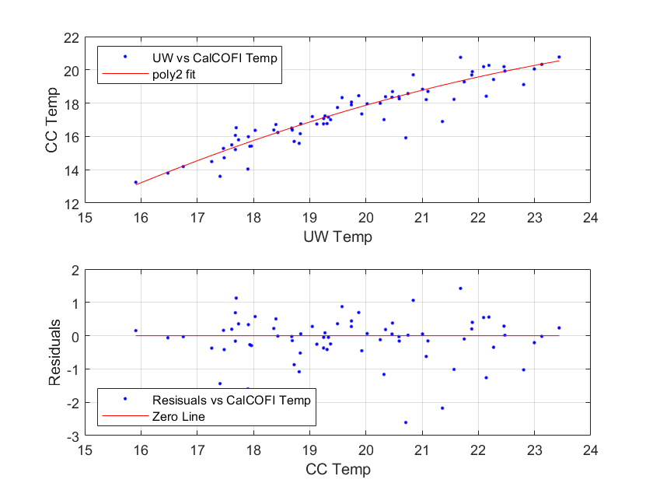

Salinity Calibration: Todd Martz TSG_Sal vs. CalCOFI Bottle
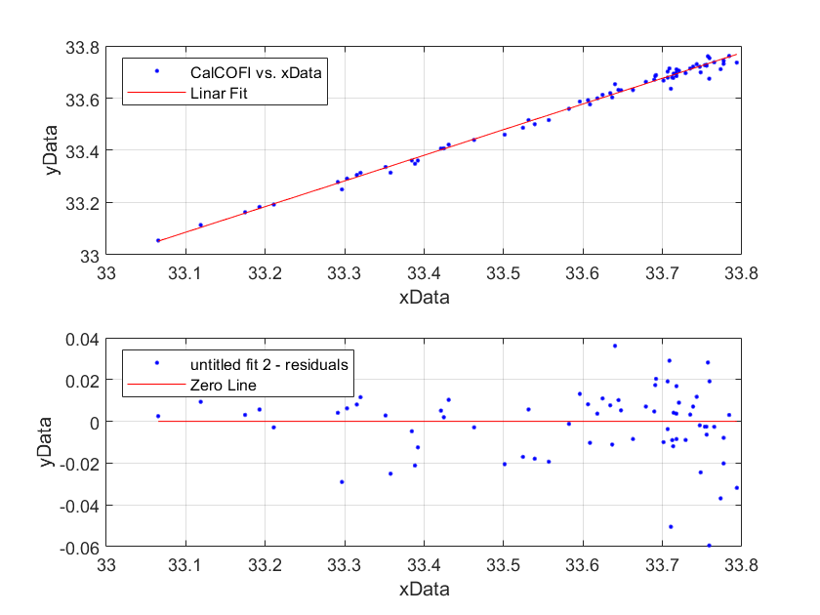

Chl-a Calibration: R/Vx Flouro vs. CalCOFI Bottle
(no data available for this cruise)

