CC1911OC Underway Data Processing Notes
The R/V Oceanus does not provide an adequate description of the sensors used in their UW system. The information below is from the ship’s website:
“Shipboard Underway Data Acquisition System (DAS): Developed in-house. Data is recorded in ASCII format. Data is readable by UNIX, PC and MAC platforms. Data displayed locally in the Main Lab. Computers on the shipboard network can access onboard data display web page. Data is available over the shipboard network during the cruise. Contact Marine Technicians for details. Data is acquired at approximately 1 Hz. Data is acquired, and stored data from the following sensors:

Navigation systems (independent Garmin/GPS-17 DGPS, bridge GPSs)
Ship Gyro Heading
HPS Heading Receiver (Thales Navigation/ADU5)
Wind speed and direction (sonic anemometer, approx. 20 m height above waterline)
Barometric Pressure (Vaislaa/PTU300)
Sea Surface Temperature, SBE 48 hull mount, SBE 38 flow through (3 m)
Sea Surface Salinity (from SBE 45 thermosalinograph, source at 3m)
Flow-through fluorometer (WETLabs WetStar)
Bottom Depth (from scientific echosounder)
Air Temperature/Humidity (Vaislaa/PTU300)
PAR Radiation
Short-wave and Long-wave solar radiation
Auxiliary wind speed
GPS Time (from Symmetricom time code receiver)
Capacitive and/or Optical Rain Gauge (on request only)
User provided sensors upon request, please coordinate in advance.”

The available UW variables from CC1911OC are:
COG – course over ground (deg)
SOG – ship speed over ground (knots)
(USWFlow – not available) – measure of water flow through the UW system (varying units)
(PARSurf – not available) – photosynthetically available radiation measured aboard the ship (uE/Sec/Meter²)
LongWaveRad – Long Wave Radiation (W/M², Pyranometer)
ShortWaveRad – Short Wave Radiation (W/M², Pyranometer)
WindSpeed – wind speed (m/sec)
WindDir – wind direction (deg)
AirTemp – air temperature (deg C)
AtmPress – atmospheric pressure (mb)
AtmPress – atmospheric pressure, sea level corrected (mb)
RelHum – relative humidity (% saturation)
TSG_Temp – water temperature measured by the STBD-TSG-Flowthrough unit (deg C)
(TSG_Temp2 – not available) – water temperature (deg C)
TSG_Cond – water conductivity measured by the STBD-TSG-Flowthrough unit (mS/cm)
TSG_Sal – water salinity calculated by the STBD-TSG-Flowthrough unit (PSU)
TSG_Dens – water density as sigma-t calculated by the STBD-TSG-Flowthrough unit (PSU)
SoundVel – sound velocity calculated by the Sally Ride’s TSG75 unit (m/sec)
(TSG_Temp_2 – not available) – water temperature (deg C)
(TSG_Cond_2 – not available) – water conductivity (mS/cm)
(TSG_Sal_2 – not available) – water salinity calculated (PSU)
(TSG_Dens_2 – not available) – water density as sigma-t (PSU)
(SoundVel_2 – not available) – sound velocity (m/sec)
(Oxygen – not available) – oxygen concentrations (mL/L)
(OxygenSat – not available) – oxygen saturation (%)
SSTemp - Sea Surface Temperature, SBE 48 hull mount (degC)
OxygenTemp – temperature of the water oxygen measurements were made on (deg C)
ChlFluor – chlorophyll fluorescence (volt). The instrument must have malfunctioned. No meaningful correlation between ChlFluor and CalCOFI bottle Chl values was observed.

Derived variables are:
Pred_Temp – temperature derived from calibrations of TSG_Temp vs. CalCOFI 0 to 12 m bottle temperatures (deg C)
Pred_Sal – salinity derived from calibrations of TSG_Sal vs. CalCOFI 0 to 12 m bottle salinity (PSU)
Pred_Chl – chlorophyll derived from calibrations of ChlFluor vs. CalCOFI 0 to 12 m bottle Chl-a (ug-Chl/L). All values are set to NaN.

Temperature Calibration: Oceanus TSG_Temp vs. CalCOFI Bottle
There are some problems with water heating in the UW pipe system likely caused by UW flow instability.
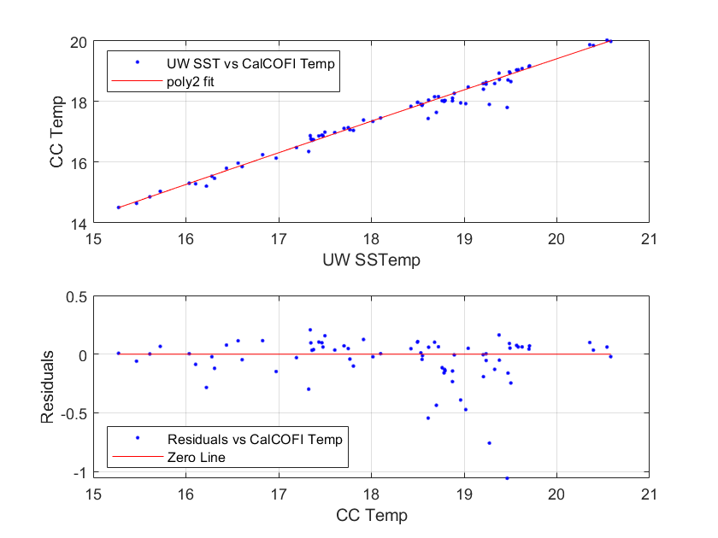

Salinity Calibration: Oceanus TSG_Sal vs. CalCOFI Bottle
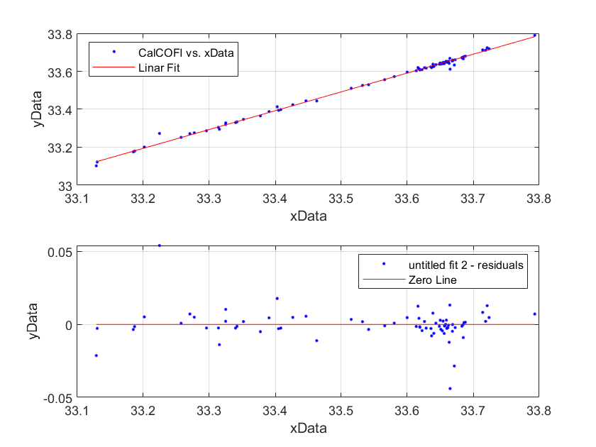

Chl a Calibration: Oceanus Flouro vs. CalCOFI Bottle
The scatter around the regression line is fairly typical for this measurement.
