CC2001RL Underway Data Processing Notes

The raw UW data were extracted from the various RL instrument files.

Notes:   
1. There are no Air temperature data. Files SAMOS-AirTemp_20200105 are virtually empty.

2. There are no SST data; files …\SeaTemp\High-SeaTemp-F_20200105-0000xx are empty.

3. The UW fluorometer did not function properly; no consistent relationship between CalCOFI bottle Chl-a and Fluor values were observed (see below). It is likely that this is due to fouling of the flow cell.



4. The radiometer was not functioning properly (see figure below). Data were good until Jan 13th.



**The available variables from these files are:**

COG – course over ground (deg)

SOG – ship speed over ground (knots)

USWFlow – flowrate of the UW system (units unknown)

LongWaveRad – Long Wave Radiation (W/M2, Pyranometer) – data after Jan 13th are suspect

ShortWaveRad – Short Wave Radiation (W/M2, Pyranometer) – data after Jan 13th are suspect

WindSpeed – wind speed (m/sec)

WindDir – wind direction (deg)

(AirTemp – not available) – air temperature (deg C)

AtmPress – atmospheric pressure (mb)

(RelHum – not available) – relative humidity (% saturation)

TSG_Temp – temperature measured by the TSG SBE 21 unit (deg C)

TSG_Temp2 – temperature measured by the TSG SBE 38 unit (deg C)

TSG_Cond – conductivity measured by the TSG SBE 21 unit (mS/cm)

TSG_Sal – water salinity measured by the TSG SBE 21 unit (PSU)

TSG_Density – seawater density calculated Temp & Sal (kg/m3)

SoundVel – sound velocity calculated by the TSG unit (m/sec)

TSG_Temp_2 – temperature measured by the TSG SBE 45 unit (deg C)

TSG_Cond_2 – conductivity measured by the TSG SBE 45 unit (mS/cm)

TSG_Sal_2 – water salinity measured by the TSG SBE 45 unit (PSU)

TSG_Density_2 – seawater density calculated from Temp & Sal (kg/m3)

(SoundVel_2 – not available) – sound velocity calculated by the TSG unit (m/sec)

(SSTemp – not available) – x

(SSSal – not available) – x

(SSCond – not available) – x

(SW_pH – not available) – x

(Oxygen – not available) – x

ChlFluor – chlorophyll fluorescence (volt).

**Derived variables are:**

Pred_Temp – temperature derived from regressions of TSG SBE 45 TSG_Temp vs. CalCOFI 0 to 12 m bottle temperatures (deg C)

Pred_Sal – salinity derived from regressions of TSG_Sal vs. CalCOFI 0 to 12 m bottle salinity (PSU)

Pred_Chl – chlorophyll derived from regressions of ChlFluor vs. CalCOFI 0 to 12 m bottle Chl a (ug-Chl/L).   
These data are not available.

**Temperature Calibration:**

Pred_Temp – temperature derived from calibrations of TSG 21_Temp vs. CalCOFI 0 to 12 m bottle

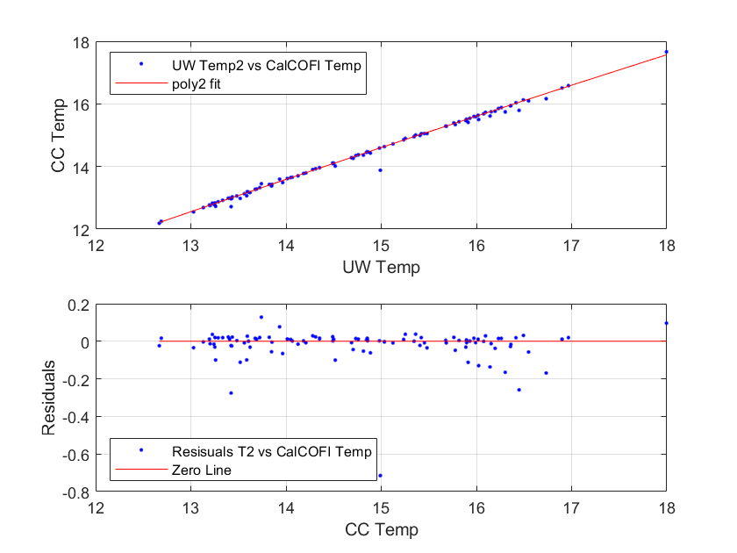

Pred_Temp – temperature derived from calibrations of TSG 38_Temp vs. CalCOFI 0 to 12 m bottle

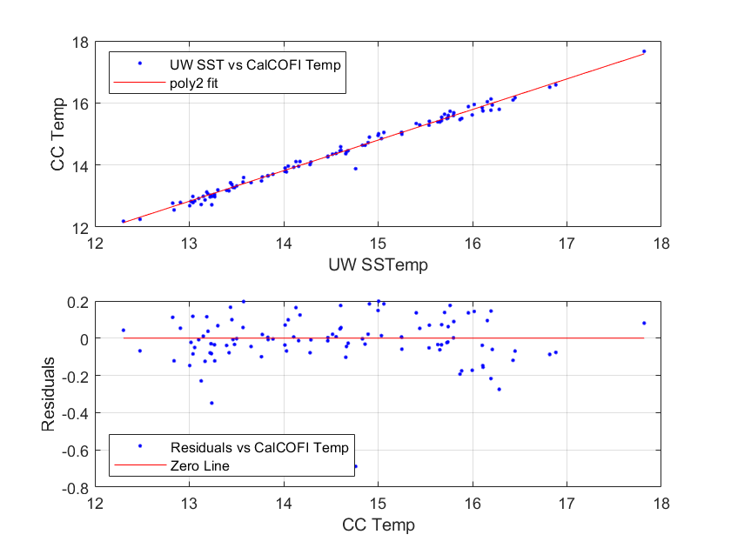

**Salinity Calibration:**

Pred_Sal – salinity derived from calibrations of TSG_Sal vs. CalCOFI 0 to 12 m bottle salinity (PSU)

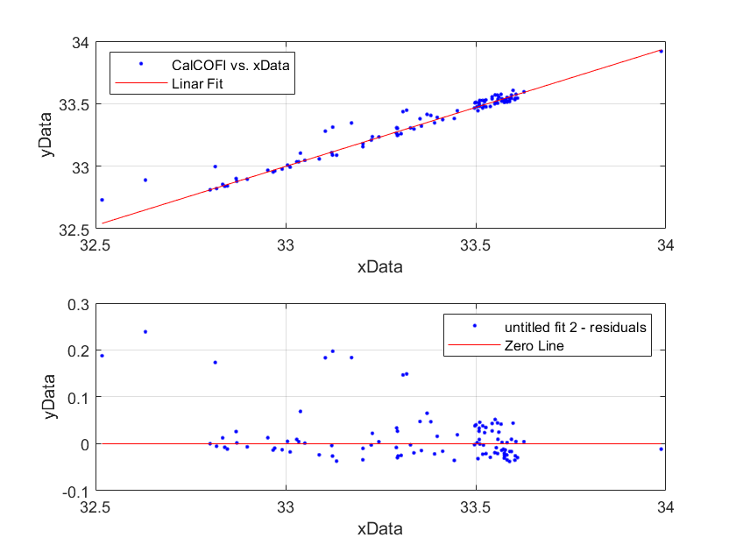

**Chlorophyll Calibration:** Pred_Chl – chlorophyll derived from calibrations of ChlFluor vs. CalCOFI 0 to 12 m bottle Chl a (ug-Chl/L)

