CalCOFI data logging

The Bold Horizon is equipped with a Maretron VDR100 vessel data recorder. It will log data from the NMEA2000 network consisting of the Ships Gyro, GPS, Wind direction/speed sensor and other vessel sensors. The VDR100 is housed in the upper winch control shack “Doghouse” on the 01-deck starboard. The VDR data is recorded to the usb stick installed in the usb port of the device. Recording is done automatically so you do not need to start or stop the recording, but you can monitor the recording using the Maretron DSM250 display.

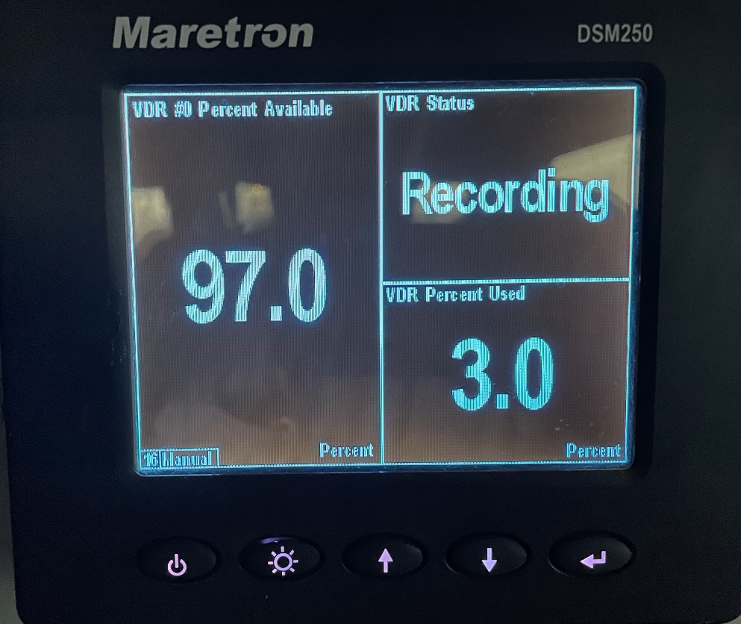

The drive was cleared and reinstalled on August 12th so the data on the drive will be current for this cruise. The drive can be removed and copied to another drive after the trip for post processing. To post process the data Maretron provides a free software N2K Extractor for viewing and exporting the data as a .csv file. In the lower lab space, the METS computer is housed where the N2K extractor software is installed onboard. The N2K extractor can be used while underway but it is not recommended to be used during critical operations to prevent data lost on the VDR.
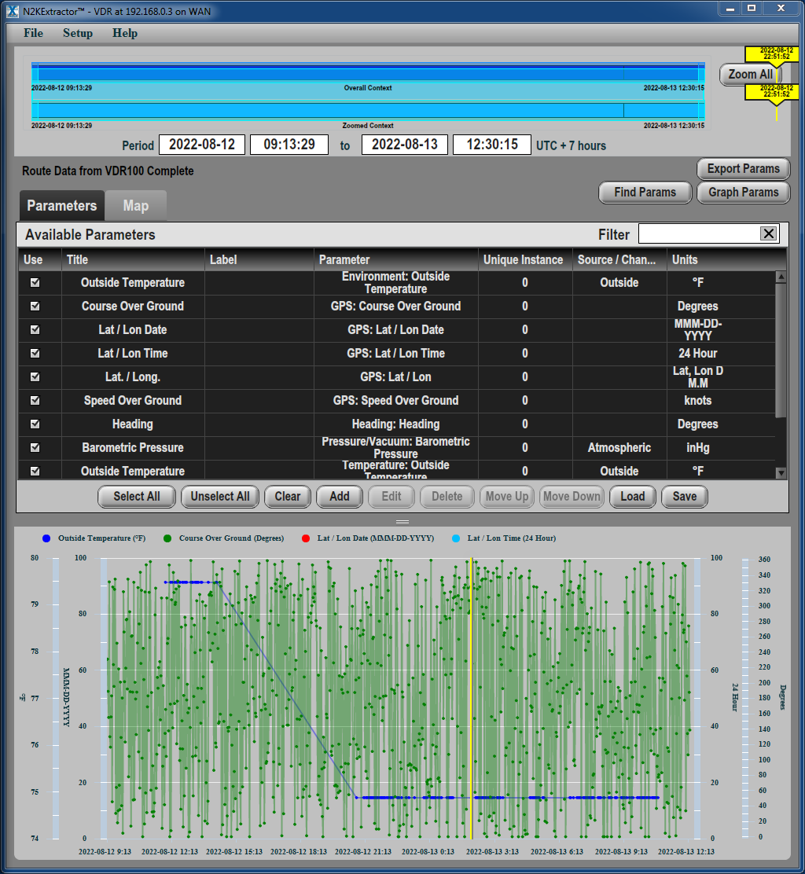

Along with the ship’s VDR, the lower lab is equipped with a TSG installed in the aft Ocean lab port bulkhead. The TSG’s serial data output is connected to the Moxa nport serial device server port 3 for data transmission on a LAN making it easier for recording or viewing. The METS computer is connected to the Moxa nport serial server, and the com port is mapped to COM37 on the computer. To log the data, use the IO tester utility software. Recording the data is achieved by pressing the record button on the IO Test window for COM 37. The button will indicate RED when recording and BLUE when not recording.
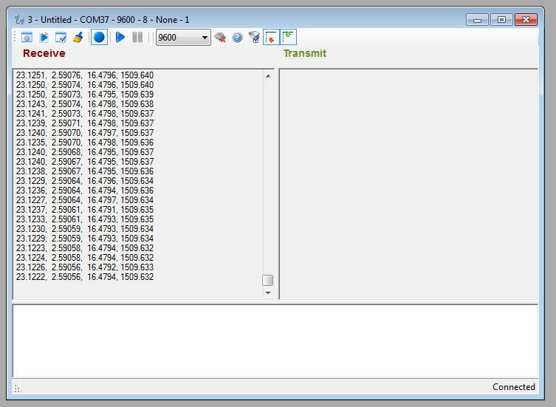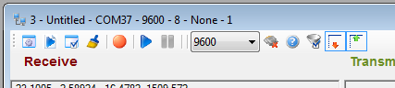

Once you press the record button you will be prompted with a file saving window. Save the file to the Data drive on the computer in the CalCOFI folder. IMPORTANTLY append the file with the date in the YYYY_MM_DD format for easier post processing. The recording should be stopped and then immediately restarted daily to keep the file sizes down and to prevent any lost of data.
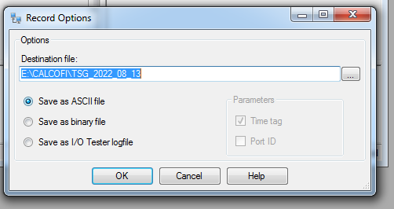

In the case of emergency or reboot, you can restart the IO tester by pressing the taskbar icon for it.
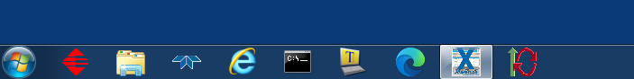

The software will prompt the following:
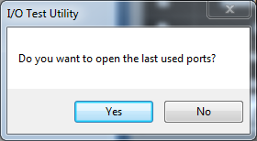

Select yes and COM 37 recording window will open but recording will NOT be started. Make sure recording is restarted and file name is corrected with an additional “crash” so data is not overwritten.

