PROCEDURES FOR CORRECTING EPPLEY PYRGEOMETER DATA
Gayle Dana
Desert Research Institute
Reno NV
March 26, 1996
revised June 27, 1996

Procedures for Correcting Pyrgeometer Data
Prepared by: | Gayle Dana  Biological Sciences Center  Desert Research Institute  Reno, NV  (702)673-7538  gdana@maxey.dri.edu
Date: | March 10, 1997; revised June 27, 1996
Overview
The Eppley PIR Pyrgeometer measures longwave (LW) radiation in the infrared (IR) electromagnetic range 4 to 50 µm. It consists of a thermopile shielded by a silicon hemisphere, or dome. The instrument output function measured most widely is the pyrgeometer output (Fig. 1, pins A-B). The pyrgeometer output incorporates a temperature compensation circuit to account for the thermopile's response variation to temperature (Fig 1., pins A-C) and also incorporates a thermistor-battery resistance circuit which compensates for radiation emitted by the thermopile (Fig. 1, pins B-C). The pyrgeometer output (R_{in}) represents the incoming LW radiation:
R_{in} = R_{net} + R_{out}
where:
R_{in} is the incoming LW radiation represented by the pyrgeometer output measured across pins A-B, R_{net} is the net LW radiative flux at the thermopile surface, measured across pins A-C, and R_{out} is the outgoing, or emitted LW radiation, measured across pins B-C, which is essentially dependent on the temperature of the thermopile. The measurement across pins B-C is also called the compensation output.
Presently the LTER has three pyrgeometers deployed in Taylor Valley: one measuring downwelling IR on Taylor Glacier and one each measuring down and upwelling IR on the Commonwealth Glacier. During the first two years of the LTER (1993/94 & 1994/95), LW radiation incoming to the sensor surface was measured using the pyrgeometer output circuit (Fig 1: Pins A-B).
The Problem
There are three problems with measuring incoming LW radiation in the configuration as described above:
- Nonlinearity of pyrgeometer performance with temperature
The pyrgeometer output (pins A-B) is nonlinear with temperature; the circuit cannot reproduce the proper temperature dependence (T_{S}⁴, where T_{S} is the temperature of the thermopile, or sink temperature), especially at very cold temperatures. Albrect and Cox (1977) show that for temperatures between 30 and -25ºC, the error due to this nonlinearity problem is less than +8 W m⁻². However, at temperatures less than -25ºC, the error increases rapidly with decreasing temperatures. For example, at temperatures in the range -45 to -55ºC, errors as high as +40 W m⁻² can occur.
- Dome-sink temperature differences
The Eppley pyrgeometer (A-B) circuitry does not account for solar heating of the hemisphere dome that covers the thermopile. Solar heating of the dome may easily produce up to a 10 ºC difference between the temperature of the dome and thermopile (sink). This may cause an error of up to 30 - 40 W m⁻². The larger the difference between the dome and the sink, the larger the output error. Periods of rapid heating or cooling cause the most significant errors, because the dome responds relatively quickly to changes in temperature, while the thermopile, surrounded by the entire mass of the case, is more slow to respond.
- Battery voltage uncertainty:
The voltage output of the mercury cells (1.32 V) used in the A-B circuit may vary slightly with age and temperature. The contact resistance may also cause some fluctuations in the actual voltage applied to the circuit. These small variations may result in large variations in the pyrgeometer output. For example, Albrect and Cox (1977) report that a 0.10 V variation in battery voltage results in a 33 W m⁻² variation in instrument output at 25 º C. While variations become absolutely smaller at colder temperatures, the relative variation may be as large.
Solution
The errors described above can be greatly reduced by measuring three different signal outputs available on the Eppley:
- The thermopile output (E) between pins A and C. When the signal across the pins A and C is divided by the sensitivity (or calibration constant), the result is net radiation at the thermopile.
- The temperature of the case (=sink)(T_{c}) measured between pins E and D.
- The temperature of the hemisphere dome (T_{d}) measured between pins F and G.
Incoming LW irradiance (R_{in}) (in W m⁻²) is calculated as the sum of three terms:
R_{in} = (E* c) + (e s T_{c}⁴) + (k s T_{c}⁴ - T_{d}⁴)) (eq. 1)
where:
E | is the thermopile voltage in mv (pins A-C)
c | a multiplier determined by the instrument sensitivity (s),  (1/s(in µvolts*W/m²)) * (1000 uvolts/mvolts)
e | is the emissivity of the thermopile surface, here e = 1
s | is the Stefan-Boltzman constant = 5.67 x 10⁻⁸ W m⁻² K⁻⁴
T_{c} | is the case temperature (=temperature of the thermopile surface), in ºK
T_{d} | is the temperature of the dome, in ºK
k | is the calibration factor determined for each instrument.
The first term represents net LW radiation, the second term is the outgoing LW radiation (or the blackbody emission of the thermopile surface), and the third term accounts for the temperature difference between the case (thermopile) and the dome. The calibration factor k is determined for each instrument and usually ranges from 2.5 to 4.0. Since k has not been determined for the three pyrgeometers presently deployed, a value of 3.5 will be used, upon advice of NOAA-CMDL. In a simple error analysis comparing LW radiation computed using a k of 2.5 and a k of 4.0 results in an average difference of ~2 W m⁻², with a maximum difference of +10 W m⁻².
At the beginning of the 1995/96 field season changes were made in the wiring and programming of the Eppley Pyrgeometers in order to measure the three outputs described above. The pyrgeometer (pins A-B) output continues to be measured so that we may compare it with the new method of calculating incoming LW radiation from the three other pin outputs. If there is a good correlation between the two methods, pyrgeometer data collected from 1993/94 and 1994/95 can be back corrected.
One additional change was made to the Pyrgeometers in 1995/96. There has been concern by both Eppley and NOAA that the mercury battery may not maintain sufficient voltage over the cold Antarctic winter. To circumvent this problem the battery was removed, and the battery connectors were wired to the cable connector on the inside of the instrument, so that the 1.32 V could be provided by the datalogger, rather than by the battery. This required that new cabling be constructed by Eppley; a separate cable bundle was added to interface sensor to the datalogger. A few datalogger program changes were necessary to measure the additional outputs and to supply the voltage from the datalogger. The details of these changes are outlined in "Re-Wiring and Programming for Eppley Pyrgeometers dated 10/30/95" and additional notes are found in "Considerations for Determining Instruction Parameters for Pyrgeometer Thermistors", dated 10/16/95. While insuring that the thermistor-battery-resistance circuit receives a stable voltage, supplying the voltage from the datalogger unfortuately results in a pyrgeometer output that is slightly different than those measured between 1993 and 1995, since during that time batteries were used. The resulting pyrgeometer output (pins A-B) in 1995/1996 will not have a battery voltage uncertainty error.
Methods for correcting LAWN pyrgeometer data
Only two met stations have pyrgeometers: the Commonwealth Glacier has two sensors, one measuring upwelling and one measuring downwelling LW and the Taylor Glacier has only one pyrgeometer measuring downwelling LW. Note that the pyrgeometer previously on the Howard Glacier (1993-1995) was moved to the Commonwealth Glacier in December 1995.
Two values for LW radiation will be stored in 1995/96 Level 1 LAWN data. The first will be the "pyrgeometer output" (pins A-B); the appropriate correction for this output, that of applying a multiplier specific to each instrument, is provided in the task sheet for each file. The second will be LW radiation as calculated from equation (1) above using measurements from the thermopile (pins A-C), case thermistor (pins E-D), and the dome or hemisphere thermistor (pins F-G). The correction procedure for the calculated LW radiation is provided in the steps below.
- Convert case (pins E-D) and dome (pins F-G) mv output to temperature
  - Calculate case and dome thermistor resistances, R_{S} from datalogger outputs, X:
R_{S} = R_{f}(1/X -1), where R_{f} is the resistance of the bridge completion resistor
here R_{f} equals 1000 ohms
X is the ratio of the thermistor measurement, (V_{S})
to the excitation voltage (V_{x}); note that this ratio, X, is
calculated and stored by the datalogger; NOTE! X must
be divided by 2500 for data past xx, 1996 (due to a
multiplier of 2500 in the CR10 program.
  - Calculate absolute temperatures (ºK) of the case (T_{c}) and dome (T_{d}) from resistances R_{S} (in ohms), using the Steinhart-Hart equation with coefficients supplied by Eppley specific to these thermistors:
T = 1/{c₁ + c₂*ln(R_{S}) + c₃*ln(R_{S})³}
where c₁ = 1.0295 x 10⁻³
c₂ = 2.391 x 10⁻⁴
c₃ = 1.568 x 10⁻⁷
- Convert thermopile output (A-C) to mv (E):
E = (A-C/250)
- Calculate LW radiation (R, in W m⁻²)(upwelling or downwelling) using equation (1)
This will be the second pyrgeometer LW radiation value stored in level 1 data for each pyrgeometer.
R_{in} = (E* c) + (e s T_{c}⁴) + (k s T_{c}⁴ - T_{d}⁴)) (eq. 1)
with
E, T_{c}, T_{d} as calculated above
e = 1
s = 5.67 x 10⁻⁸ W m⁻² K⁻⁴
k = 3.5 (for 1995/1996 data)
c = multiplier specific to each instrument:
Commonwealth downwelling LW, c = 256.41
Commonwealth upwelling LW, c = 249.38
Taylor downwelling LW, c = 248.76

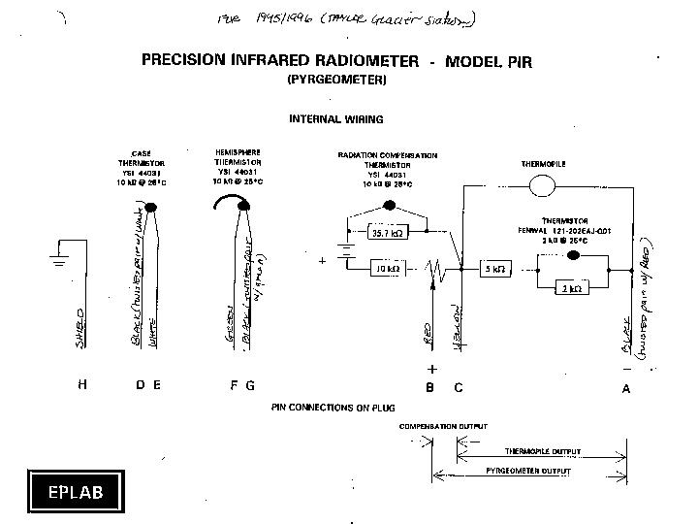

Go to: MCM Dry Valley Meteorology Datasets
MCM LTER home page

